Project Report

|  |  |
| --- | --- |
| **Project Title** | Design, Develop, Implement, Test & Document Used Car Sales Portal Website |
| **Qualification Name (NICF)** | Advanced Certificate in Software Applications (Development and Process) |
| **Product Name** | ABC Cars Pte Ltd Portal |
| **Module Name (NICF)** | Application Development & Process |

|  |  |  |  |
| --- | --- | --- | --- |
| **Student name** | | **Assessor name** | |
| Muhammad Kemal | |  | |
| **Date issued** | **Completion date** | | **Submitted on** |
|  |  | | 10/05/2023 |
|  | |  | |
| **Project title** | **Design, Develop, Implement, Test & Document Used Car Sales Portal Website** | | |

|  |
| --- |
| **Learner declaration** |
| I certify that the work submitted for this assignment is my own and research sources are fully acknowledged.  Student signature:  Date: 10 May 2023 |

**Content**

1. **Project Background**
2. **Project Objectives**
3. **Project Requirement Specifications**
4. **Task 1**
5. **Task 2**
6. **Task 3**
7. **Task 4**
8. **Task 5**
9. **Task 6**
10. **Task 7**
11. **Task 8**

1. **Project Background**

A used automobile sales portal that allows customers to register and search for vehicles based on make, model, registration, and price has been requested by ABC Cars Pte Ltd. The logged-in users can utilize the portal to carry out a number of tasks, including reading car data, logging in, listing cars for sale, changing their profile, scheduling test drives, placing bids on cars, and deactivating their posts.

There will be two roles in the portal: one for administrators and one for users. Administrators will be able to designate users as administrators, approve bookings based on bidding, and conduct sales in addition to basic functionalities.

The portal will be developed by using the Spring Boot framework with Spring Security, Spring Data JPA, MySQL server, and Risk Based Testing (RBT). Spring Boot will make development faster and easier by reducing boilerplate code, while Spring Security will provide authentication and authorization protection. Spring Data JPA will simplify the Data Access Layer by building Java interfaces that include data access technologies such as custom finder methods. MySQL server will be used for reliable data management and connectivity, while RBT will be used for testing the functional and non-functional requirements of the portal based on critical assessments of risks.

1. **Project Objective**

The objectives of this project include performing the following:

* To design, develop a used car sales portal using Spring Boot framework, Spring Security, Spring Data JPA and MySQL server.
* To implement the Risk Based Testing (RBT) strategy or spiral SDLC model on the used car sales portal to prepare the testing plan for validation of the client requirements.
* To document the used car sales portal website based on spiral model and execute and recording necessary testing under RBT.
* To identify and analyze the risks associated with the used car sales portal and solving the problems based on the RBT test plan.

**Tools & platform used**

|  |  |
| --- | --- |
| Software | Purpose |
| Spring Tool Suite 3 | Java IDE used to develop web application based used car sales website |
| MySQL Workbench | Visual database design tool that allows to create, manage, and administer MySQL databases. |
| Lambdatest.com | Used to conduct cross-browser testing |
| Ngrok | Used to generate a forwarding URL for cross-browser testing |
| Microsoft Word | Used to write Application Development & Make report or documentation |

|  |  |
| --- | --- |
| **Spring Tool Suite 3** | **Spring Tool Suite 3** |
| Ngrok | Microsoft Word |
|  |  |

1. **Project Requirements Specifications**
   1. **Project Scope**

The used car sales portal is accessible to two types of users: Users and Administrators, both of them has certain functionalities assigned to them, as specified in the following list:

**3.2 User**

* Register Page
* Login Page
* Post the Car for sale
* View Car Details
* Visit Home Page
* View Car Listing
* Search Car by make, model, registration & Price Range
* Bid for the car
* View About Us Page
* View Contact Us Page
* Logout

**3.3 Admin**

* Login into administrator panel
* Manage Car
* Logout
* Visit Home Page
* View Car Listing
* View About Us Page
* View Contact Us Page
* Search Car by make, model, registration & Price Range

**3.4 Functional Requirement**

The following pages will be developed and displayed in the project:

* Registration Page
* Login Page
* About Us Page
* Home Page
* Post Car Page
* Car List Page
* Biding Page

1. **Task 1**

**Task Statement:**

Create the following items Under “Business Process Section” in Project Presentation

1. Explain the Business Processes the Software is supporting
   1. Document 2 Business Process
2. Document 2 Module functionality
   1. UI Screenshots
   2. Functionality of each of the Screen

**Solution:**

* 1. **Explain the Business Processes the Software is supporting**
  2. Document 2 Business Process
     1. Scenario 1 - Post Car

1. Enter the URL <http://localhost:8080> to access the used car sales portal
2. Click ‘Register’ and enter name, username, email and password to register as new user
3. User will see a register success message with link to login page
4. Enter registered account in the login page
5. If the credentials is valid the user will then see the home page with the list of cars posted by other registered user
6. Click ‘Sell Now’ in the home page or in the profile page In order to post a car for sale fill all the requirement such as “the name of the car, model, price, make year, registration, date, and car photos” and then click on post
7. After filling in all the requirement The user will see the success message and finally the can see their car in the home page, and in their profile.
   * 1. Scenario 2- Bid Car
8. Enter the URL http://localhost:8080 to access the used car sales portal
9. Click ‘Register’ and enter name, username, email, and password to register as a new user
10. User will see a register success message with a link to the login page
11. Enter the registered account on the login page
12. If the credentials are valid the user will then see the home page with the list of cars posted by other registered user
13. User can bid for a Car on the car details page by clicking the ‘view car details’ button below each Car section which is posted by other users
14. After going to the car details page click on the ‘bid’ button to start offering the car, User has to input the bid amount and click submit
15. If the bid amount is less than the current price of the car, it will show an error message which is saying that ‘the bid amount is too low and the user has to input a higher bid amount than the current price of the car
    1. **Document 2 Module functionality**
    2. *UI Screenshots*
16. Scenario 1 – Post Car

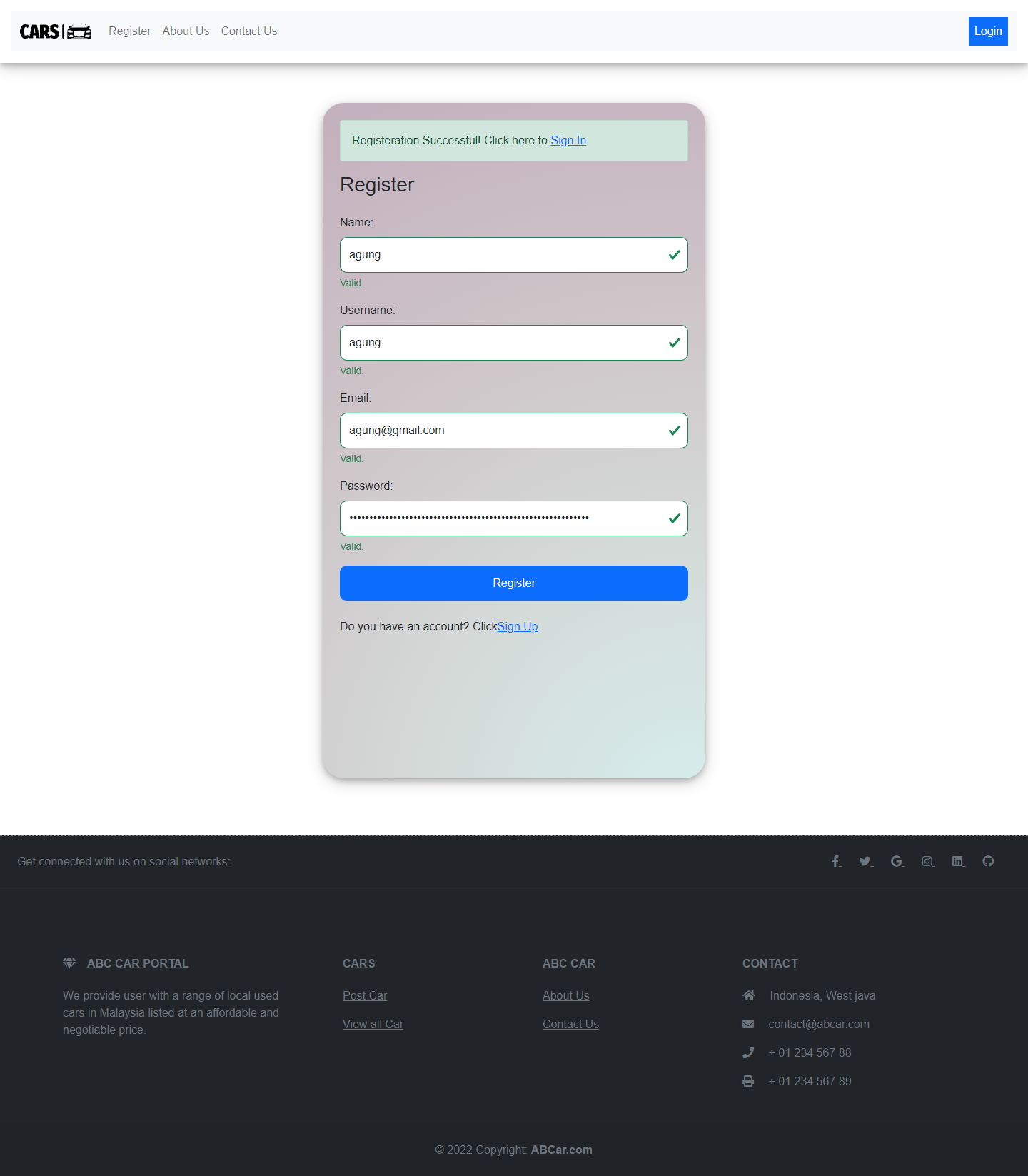

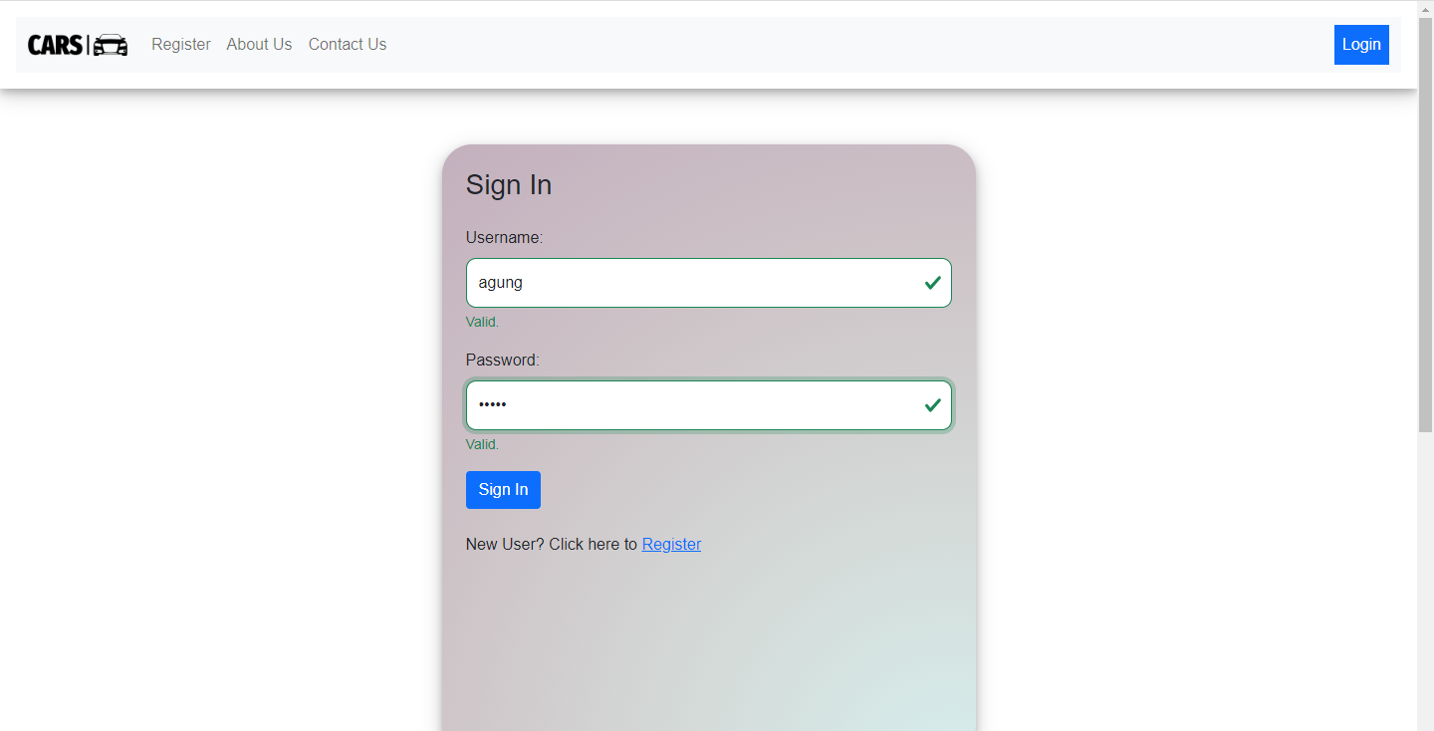

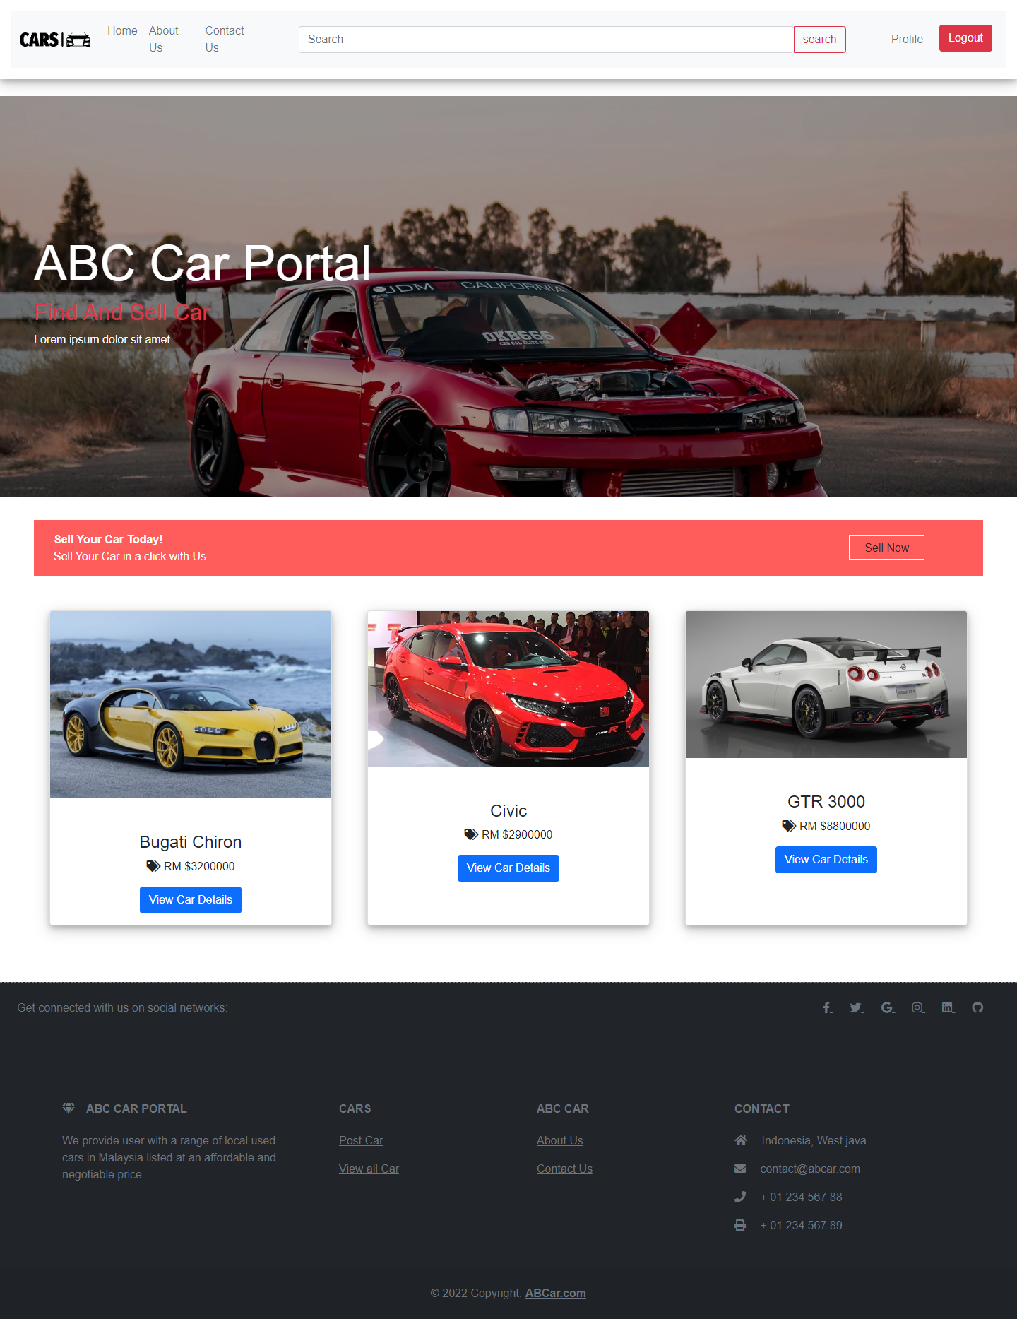

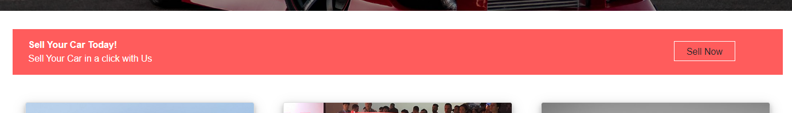

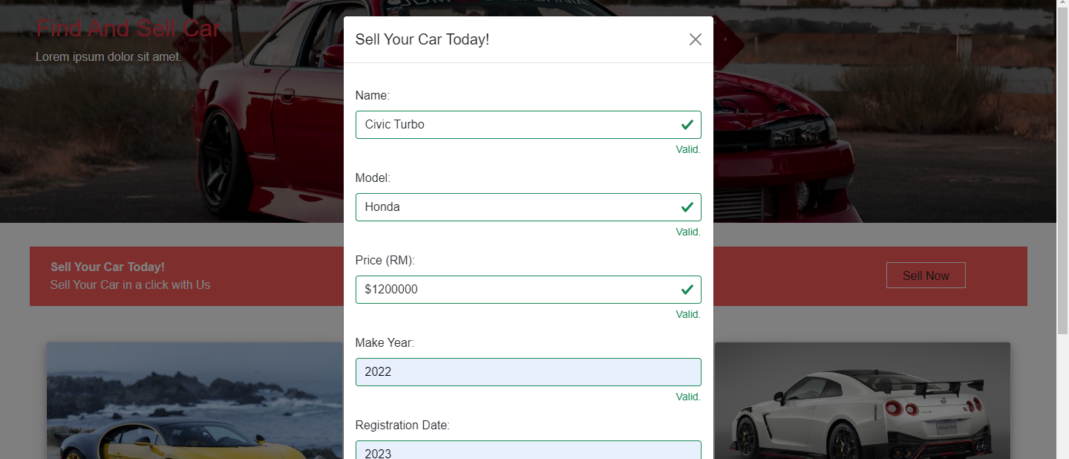

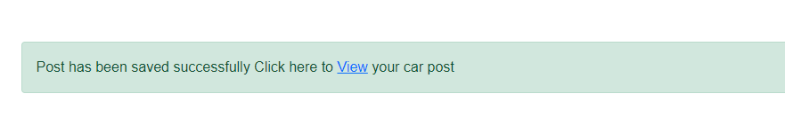

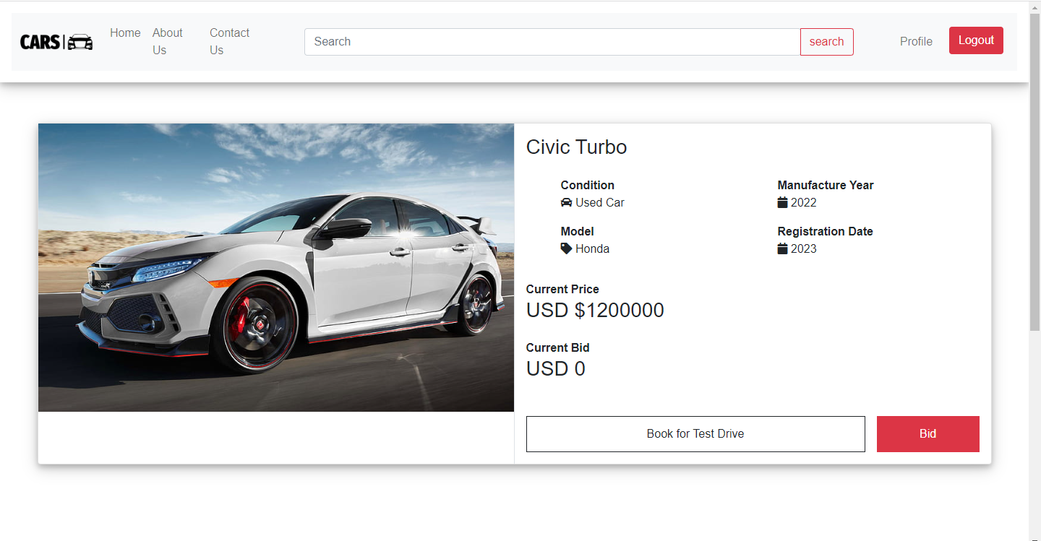

1. Scenario 2 – Bid Car

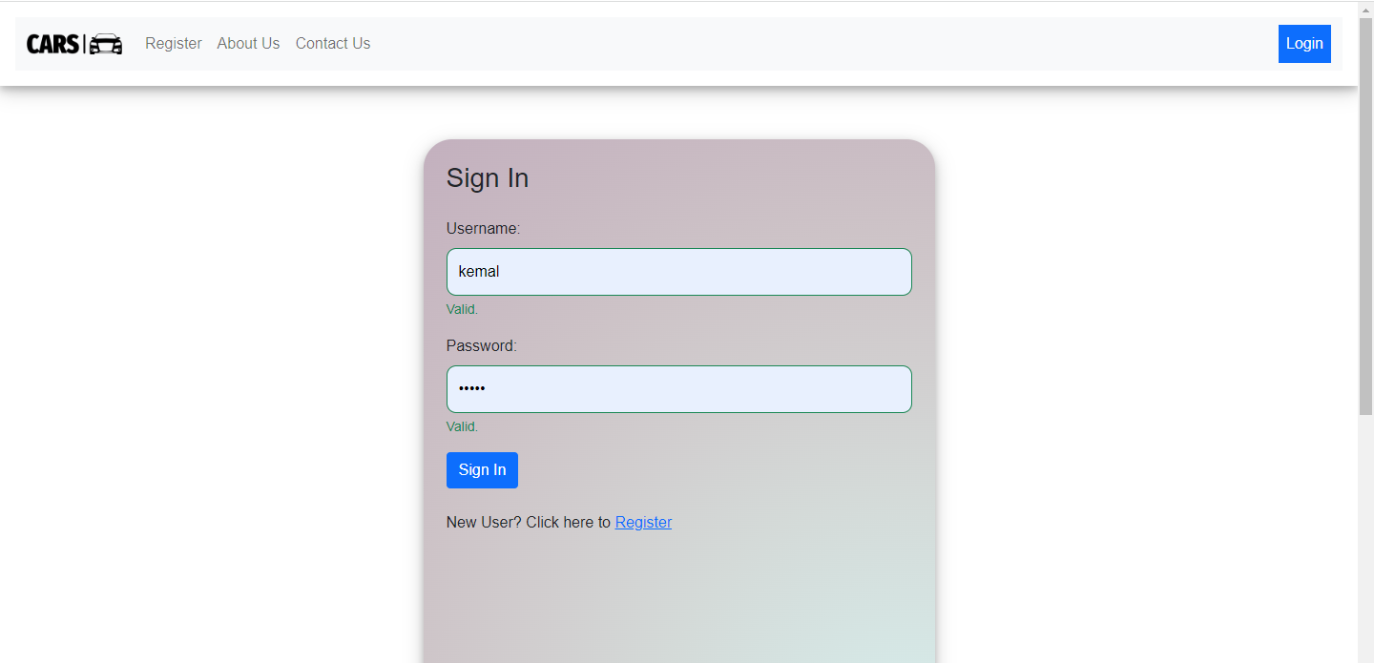

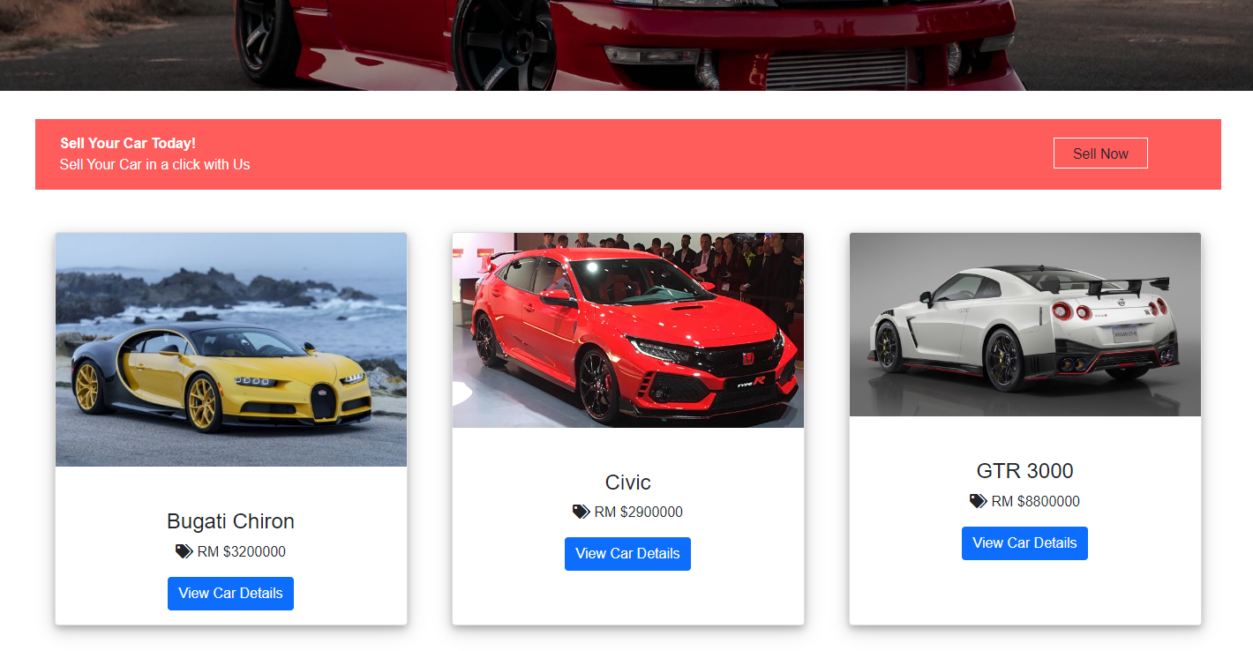

Click bid button to start bidding the car

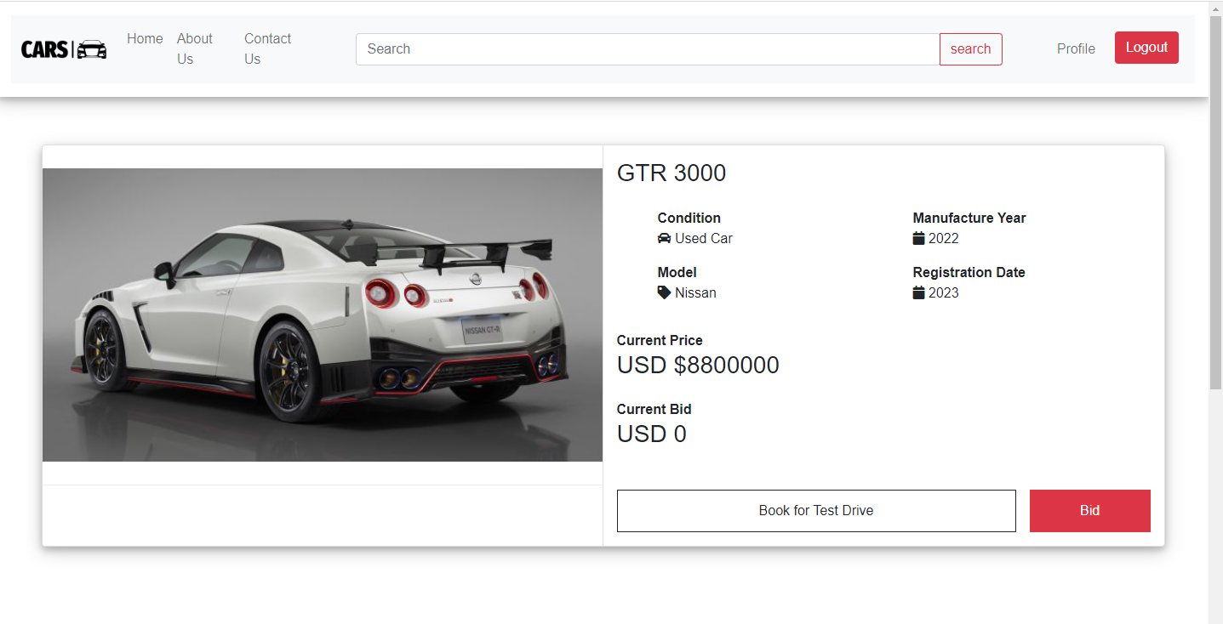

if the bid is not filled

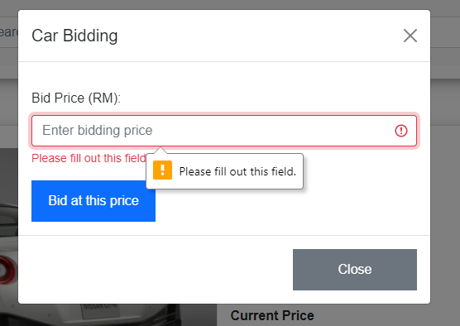

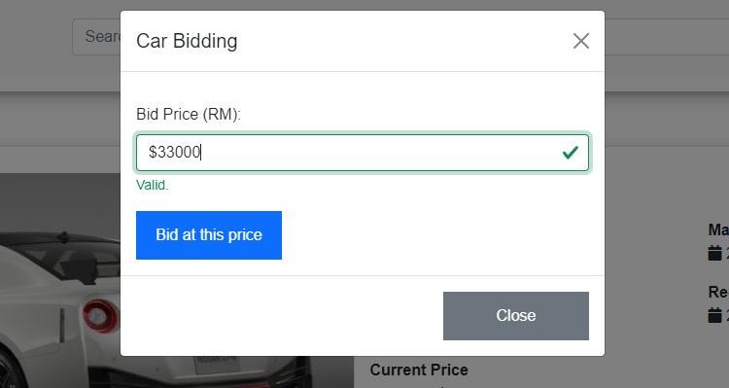

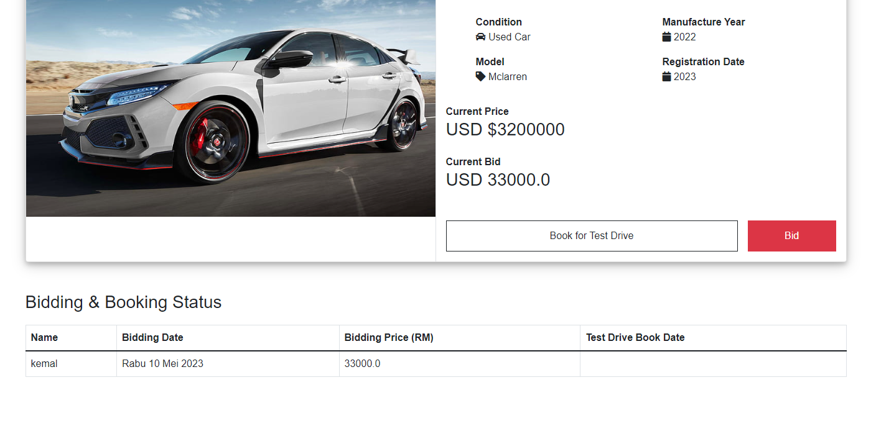

* 1. *Functionality of each of the Screen*

|  |  |
| --- | --- |
| **Pages** | **Functionality** |
| Register | To register new user for the abc car portal by storing user’s information such as user’s name, username, email and password |
| Login | To validate user registered credentials, username and password before user can actually access the portal |
| Home | The first page seen by user after successful login which contains list of all car posted and post a car sale form |
| Car Detail | Allows user to see the car details after they are posting a new car for sale or selecting the listing car detail button from selected list of all car in home page or search results |
| Search Result | The result page after user search for car according to the details of the car such as make, model, registration or price in the search bar located on the header and showing the list of car matching to the search keyword |
| Profile | In this page user is allowed to update profile their detail information such as mobile, address, avatar. Also user can track posted car sale and booking status or removing the posted car for sale |
| User Management | To allow administrator to view and manage list of registered users, this page can only access by administrator, administrator can do various functionality such as mark a user as administrator or update their profile or delete the user |
| Car Management | Same as user management page, in this page Administrator can perform varios functinality to manage all the posted car in the portal such as delete car post, update status for user booking based on bidding or updating status for car sale |
| About Us | Page seen by user which contains description about the abc used car sales portal |
| Contact Us | Page seen by user which contains contact information to reach abc used car sales |

1. **Task 2**

**Task Statement:**

Create the following items in “Project Plan in Project Presentation

1. Detail the Software Development Methodology to be used for developing system
2. List the various tasks to be done during various phases
3. Create the Project Plan detailing the various steps to be carried out along with dates and Timelines

**Solution:**

* 1. **Detail the Software Development Methodology to be used for developing system**

**Spiral model**.

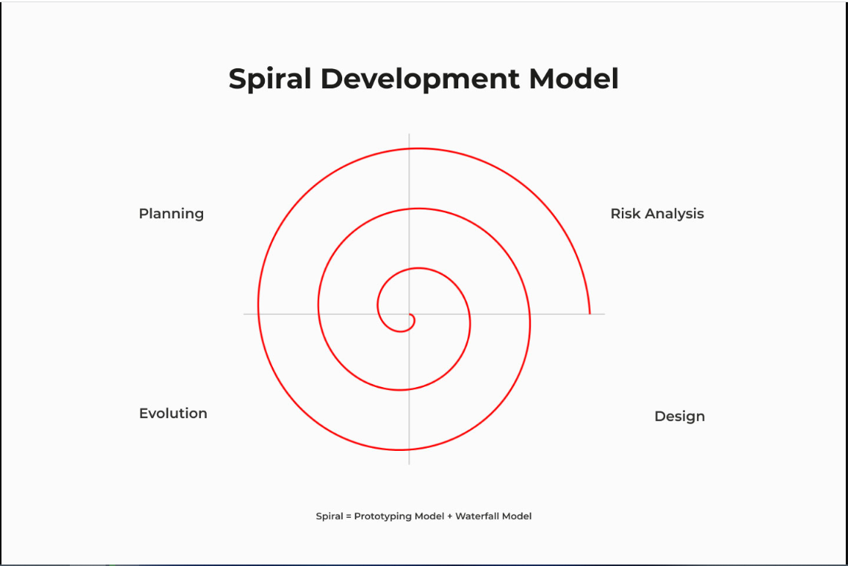

**Reason for selecting this model**

A software development process called the spiral model combines aspects of waterfall and iterative development models. Large, complicated projects that require rigorous risk management, teamwork, and flexibility can benefit from it. For projects with hazy or shifting needs, it offers a clear structure for communication and permits adjustments throughout development.

Small component cost estimate and quicker development are two benefits of the spiral approach. Returning to the development and testing stage allows for efficient change. All things considered, it's a wise decision for software development projects that demand rigorous risk management, teamwork, and adaptability.

* 1. **List the various tasks to be done during various phases**

1. **Planning & Requirements Gathering :**
2. Arrange a meeting with the client to discuss and obtain the necessary information related to the business requirements for the website.
3. Project must clearly define the objectives of the project.
   1. To design, develop a used car sales portal using Spring Boot framework, Spring Security, Spring Data JPA and MySQL server.
   2. To implement the Risk Based Testing (RBT) strategy or spiral SDLC model on the used car sales portal to prepare the testing plan for validation of the client requirements.
   3. To document the used car sales portal website based on spiral model and execute and recording necessary testing under RBT.
   4. To identify and analyze the risks associated with the used car sales portal and solving the problems based on the RBT test plan.
4. Identify the functional and non-functional requirements for the software. This involves gathering information from stakeholders, analyzing the user needs, and defining the scope of the project.
5. Functional requirement
   * + 1. User will be able to registered and login in the portal
       2. User able to post, bid, and book for a car
6. Non – Functional requirement
7. Implement Security
8. Test the performance
9. Identify the constraints that will impact the project such as budget, time, and resource limitations.
10. Identify the needs which includes what is ? and what is not ? included in the application
11. Develop a plan for the project that outlines the project schedule, resource allocation, and risk management strategies.
12. **Risk Planning / Analysis :**
13. Identify what could be the risk that will impact the project. Risk identification can be done through brainstorming sessions, interviews with stakeholders, and reviewing historical data.
14. evaluate each risk to determine its likelihood and potential impact.
15. prioritize the risks based on their potential impact on the project.
16. develop and implement strategies to mitigate the risks.
17. review the risk management plan to ensure that it is still effective and relevant.
18. **Design,development and testing :**
19. Technical **Minimum** Specification
    1. Hardware

* Processor :
* Installed RAM : 4gb
* System type: Windows 64-bit
  1. Software
* Web Server : Apache server
* Web Browser : Goggle Chrome
* Development environment: JDK 1.8.0
* Framework: Spring 3.9.10
  1. Database
* Database server : MySQL
* Database scripting: SQL Script
* Database client: MySQL Workbench

1. User Interface (UI/UX)
2. Wireframes
3. Process Flow
4. Storyboard
5. Prepare integration document
6. Define the business rules

* Only user can post a car for sale

1. Define the data exchange method from database to user interface
2. Prepare a software development
3. Database Design

* Entity-Relationship Diagram
* Logical Diagram

1. Front-End implementation

* Develop all JSP pages, CSS, Javascript

1. Back-End implementation

* Develop the entity
* Create a repository
* connect the business process

1. Prepare test case document
2. Define the test case for unit testing

* Validate registration function

1. Conduct Unit Testing
2. Review the test case
3. Run the test cases
4. Record the result

* Compare expected to actual result
* Record the result status either success or fail

1. Check the accuracy and debug
2. Make relevant changes to the front end web pages
3. Conduct user acceptance testing (UAT)

* Define the UAT test case
* Run the UAT test case
* Record the result

1. **Evaluation :**
2. Prepare website demo for the customer
3. Gather feedback form customer and satisfaction
4. Make changes to the website based on customer feedback by going back to the development and testing phases if customer approval not achieved yet
5. Proceed next phase until the customer give approve and website is fully developed
6. Confirm website has developed as well as SRS Document
7. Obtains approval from the customer to deploy the software. This includes presenting the software to the customer and obtaining their sign-off on the deployment plan.
8. Product ready for deployment

Upload develop used car portal website on web server

* 1. **Create the Project Plan detailing the various steps to be carried out along with dates and Timelines <less than a month> 20-30**

|  |  |  |  |
| --- | --- | --- | --- |
| Phases | Activity | Start Date | End Date |
| Planning | Set up a meeting with the client to determine the needs of the website's business. | 26/4/2022 | 26/4/2022 |
|  | Prepare the Statement of Work  (SOW) – Project scope | 27/4/2022 | 27/4/2022 |
|  | Define Project Objective | 27/4/2022 | 27/4/2022 |
|  | Identify the functional and non functional requirement | 27/4/2022 | 27/4/2022 |
|  | Identify the constraint (Budget, Time, etc) | 27/4/2022 | 27/4/2022 |
|  | Resource planning | 27/4/2022 | 27/4/2022 |
|  | Identify the needs | 27/4/2022 | 27/4/2022 |
|  | Develop a plan | 28/4/2022 | 28/4/2022 |
|  |  |  |  |
| Risk Analysis | Arrange a meeting and Identify what could be the risk that will impact the project. | 28/4/2022 | 28/4/2022 |
|  | Prepare risk strategy & assessment – Qualitative risk analysis chart | 28/4/2022 | 28/4/2022 |
|  | Mitigate the risk | 28/4/2022 | 28/4/2022 |
|  |  |  |  |
|  |  |  |  |
| Development & Testing | Define Technical specifications | 29/4/2022 | 29/4/2022 |
|  | Prepare user interface | 29/4/2022 | 29/4/2022 |
|  | Prepare database design | 29/4/2022 | 29/4/2022 |
|  | Front-end implementation | 29/4/2022 | 30/4/2022 |
|  | Database implementation | 30/4/2022 | 30/4/2022 |
|  | Business logic implementation | 30/4/2022 | 1/5/2022 |
|  | Prepare test cases for testing | 1/5/2022 | 2/5/2022 |
|  | Conduct UAT | 2/5/2022 | 2/5/2022 |
|  | Record testing result | 2/5/2022 | 2/5/2022 |
|  | Check accuracy and debug | 2/5/2022 | 2/5/2022 |
|  | Make relevant changes to front-end | 2/5/2022 | 2/5/2022 |
|  |  |  |  |
|  |  |  |  |
| Evaluation | Prepare website demo for customer | 3/5/2022 | 3/5/2022 |
|  | Retrieve feedback from customer | 3/5/2022 | 4/5/2022 |
|  | Project sign off between client and project manager | 4/5/2022 | 4/5/2022 |
|  | Used car sales portal ready for deployment | 5/5/2022 | 5/5/2022 |

1. **Task 3**

**Explain risk-based testing concepts and requirements with the following details**

**Solution:**

**3.1.1. Stages involved in RBT model**

* + 1. What is the risk?

Risk is the possibility that a choice you make or a course of action you follow will have a negative outcome. The greater the likelihood that anything negative will occur and the more severe its effects, the greater the risk.

* + 1. RBT stages

Risk-Based Testing (RBT) is a testing strategy in which the testing process is directed by the concepts of risk management.

* + - 1. Risk identification

Various ways to identify risks in software development:

1. Brainstorming
2. Requirement analysis
3. Historical data analysis
4. Interviewing etc.

The risk can also be categorized into 3 categories of:

1. Known risks:These are recognized risks that can be found and evaluated using historical information, historical data, or project knowledge.
2. Unknown risks: These are hazards that materialize during the project's testing phase but were not foreseen beforehand (e.g., unexpected software behavior, testing delays brought on by sudden defects emerging).
3. Unknowable risks: Unforeseen hazards, such as system outages lasting more than a day and natural disasters, could have a serious impact on the project.

Documenting the identified risks in a spreadsheet or risk register is an essential component of risk management in software development.

* + - 1. Risk Strategy & Assessment

Project managers can use the risk matrix to evaluate how likely a risk is to materialize and how much it would impact the project. Project managers can prioritize which hazards require the greatest attention by giving them a value on a scale. It's a strategy to guarantee that hazards are recognized and handled in a methodical and efficient manner.

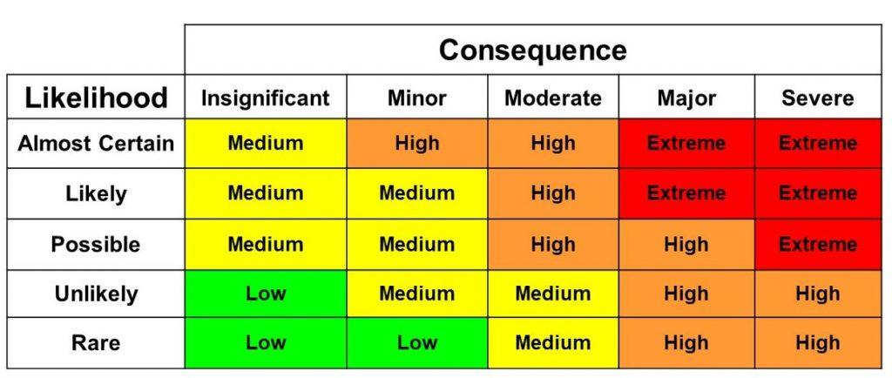

* + - 1. Risk Mitigation

Developing a response strategy to manage risks comes next once risks have been identified and evaluated. The response plan can comprise either getting rid of the danger or lessening its effects to a manageable level. This is known as risk minimization, and it is an important aspect of risk management in software development.

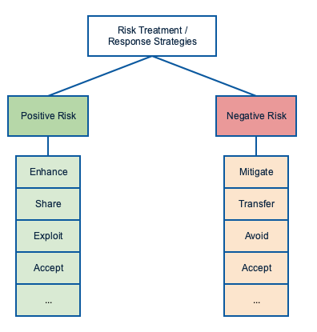

* + - 1. Risk Monitoring and Control

Monitoring and controlling risks entails keeping an eye out for those that may still exist and recognizing any new ones that may appear as the project progresses. The team can employ techniques including risk reassessment, auditing, trend analysis, and project status updates in meetings to monitor and control risk.

3.1.3 Eight characteristics of Software Product Quality

*<***The learner needs to follow ISO standards (ISO/IEC 25010:2011) to create test cases>**

The goal is to create a used automobile sales platform that complies with ISO/IEC 25010:2011 for software product quality. Therefore, it is necessary to verify the website's suitability in terms of functionality, performance, compatibility, usability, dependability, security, maintainability, and portability.

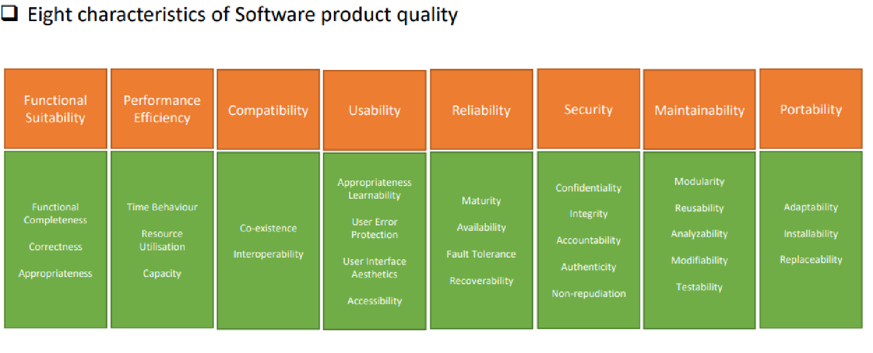

Definition of each characteristics :

1. Functional suitability – How the software meets specified functional requirements and user objectives.
2. Performance efficiency - the performance relative to the amount of resources used under stated conditions.
3. Compatibility - the degree to which the software can be used with different hardware, software, or other systems.
4. Usability – Is the software is easy to learn, operate, and understand or not.
5. Reliability - the degree to which the software can perform its required functions under stated conditions for a specified period of time.
6. Security - the degree to which the software protects information and data from unauthorized access and other security risks.
7. Maintainability - the degree to which the software can be modified and maintained, and the effort required to do so.
8. Portability - the degree to which the software can be transferred from one environment to another.
   1. **Types of Risk**

|  |  |  |  |
| --- | --- | --- | --- |
| Type of risk | Risk identification | Risk description | Impact |
| Functional | Login risk | User is not able to login | Users won't be able to enjoy all of the functions offered by the website if they are unable to log in. |
|  | Searching risk | User is not able to seach a car | The user must search manually to find a specific car because it is difficult to do so through the portal. |
|  | Posting a car risk | User is not able to post his car | The user cannot use the site to post a car for sale. |
|  | Viewing car detail risk | User is not able to view selected car details | User cannot place a bid, make a reservation, or view the details for a certain automobile. |
|  | Data is not saved, deleted, or updated in the database | No rows affected during the operation | The application won't function properly in its entirety or with some features. |
| Non-Functional Risk | Performance | Home page is not loading in expected time | The user would eventually choose another website that better suits their demands after losing interest and patience in the first one. |
|  | Compatibility | Home page has different look and feel into different browsers | User will lose interest due to the difference of user interface |
|  | Maintainability | Used car portal cannot be modified or make changes | User will judge the portal as not up to date |
|  | Usability | The portal is not easy to navigate and does not have clear label or instructions to use | users may find it difficult to learn and use the software, leading to frustration and potential abandonment of the product. |
| Technical Risk | Security | The user is not authenticated correctly after logging in | User will not be able to log in to the portal and reach the home page |
|  |  | Navigation is not properly authorized based on the user's login role assigned | The user will have unauthorized access to sensitive information or functionality |
|  |  | SQL injection | it can lead to data breaches, loss of sensitive information, and compromise of system integrity |
|  | Portability | Used car sale portal look and feel is different in phone/mobile devices | Users who are accustomed to utilizing a particular gadget will stop using the website. |

1. **Task 4**

**Task Statement**

Create the following items under “Test Planning” in Project Report

1. Establish the test phases of security testing with its prioritization
2. Develop the detailed test plan with test cases based on quantitative risk analysis
3. Create a test risk matrix with the evaluation of the impact

**Solution**

* 1. **Establish the test phases of security testing with its prioritization.**

**(a) RBT Test Strategy in car portal project**

1. What is security testing ?

Software testing that focuses on finding holes and flaws in a system's or application's security defenses is known as security testing. To make sure that the system or application is safe from potential risks like hacking, unauthorized access, data breaches, and other cyber-attacks, security testing is conducted.

2. Types of Security Testing

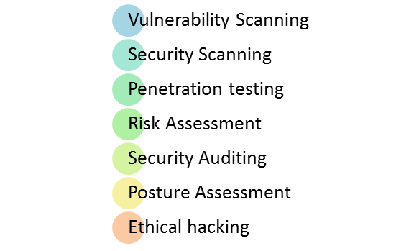

* Vulneralibility scanning : identify known vulnerabilities in the system or network.
* Security scanning : This can be done either manually or using automated tools to identify weaknesses in the system and network, with the aim of reducing the risk.
* Penetration testing : An external attack simulation is carried out to identify potential vulnerabilities in the system or network.
* Risk assesment : This involves analyzing security risks and classifying them as low, medium, or high, and identifying measures to reduce them.
* Security auditing : This involves inspecting the code line by line to identify security flaws.
* Posture assessment : Ethical hackers are employed to identify security flaws in the system.
* Ethical hacking : This involves combining security scanning, ethical hacking, and risk assessment to determine the overall security posture of an organization.

**(b) Among test strategies, how to carry security testing.**

The Security Testing Methodology for The ABC Cars Project

The process of discovering, assessing, and analyzing potential risks that might have an impact on an organization's operations, assets, or goals is known as risk assessment. Determine the possibility and impact of these risks by identifying potential threats and vulnerabilities that could have an impact on the organization. There are various steps in the procedure.

1. Risk Identification: In order to do this, it is necessary to identify potential threats to the company, such as natural disasters, cyberattacks, and other security-related incidents.
2. Risk Analysis: The likelihood and impact of each identified risk are evaluated in this step. While the impact of the risk is derived by taking into account any potential negative effects, the likelihood is determined by taking into account the possibility that the risk will actually occur.
3. Mitigating the risk : This step involves developing strategies to manage and mitigate identified risks.

**(c) Test phases in security testing**

Every stage of the software development life cycle (SDLC) must include security testing in order to guarantee that the finished product is secure.

1. Requirement phase: conduct a security analysis to check for any potential misuse cases that could pose a security risk.
2. Design: identify potential security issues and plan for how to address them.
3. Coding and Unit testing: should be conducted by testers who have knowledge of the internal structure of the website code.
4. Integration testing: test the functionality of the website without considering the internal system design.
5. System testing: testing and vulnerability scanning should be conducted to identify any potential vulnerabilities in the complete website.
6. Implementation: penetration testing should be conducted to simulate an attack from a malicious hacker, along with vulnerability scanning.
7. Support: patches and software updates should be implemented to address any vulnerabilities identified during testing.

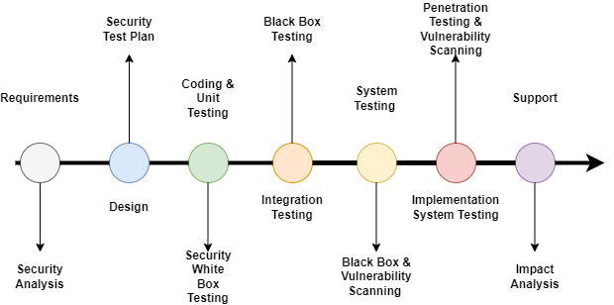

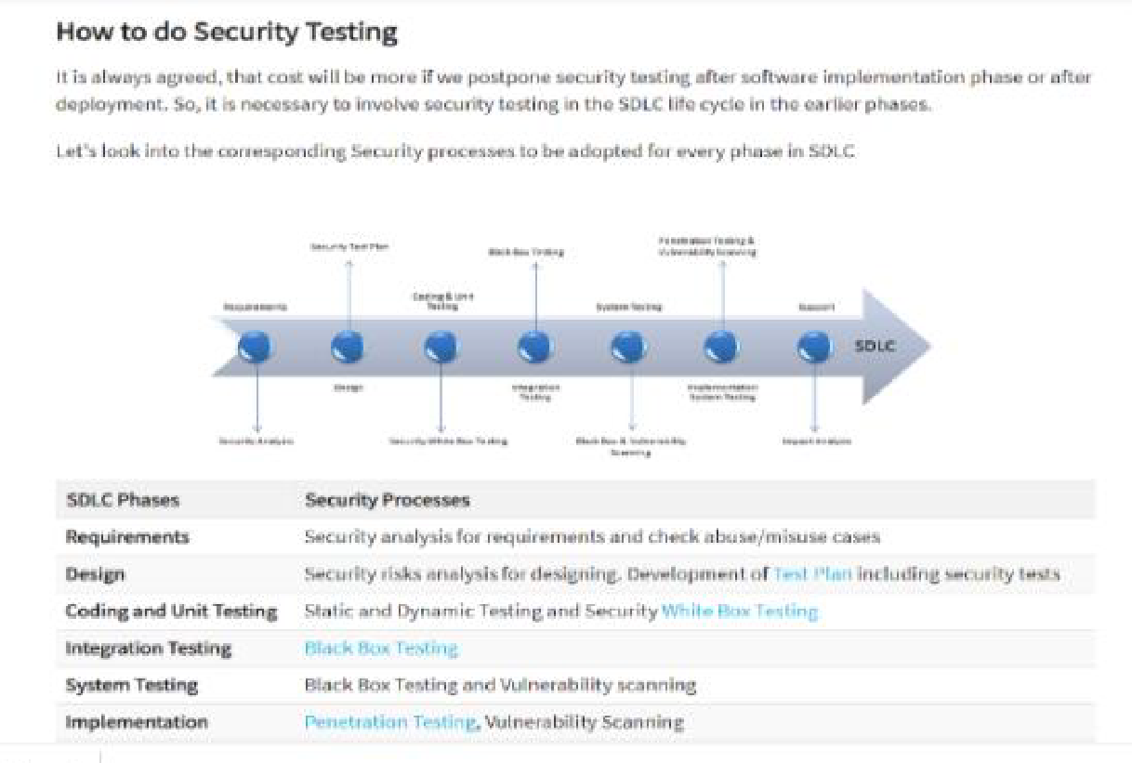

* 1. **Develop The Detailed test plan with test cases based on quantitative risk**
     1. The testing plan for the used car portal includes the following testing

1. Functional Testing - UAT test cases - 5 atleast
2. Compatibility - Cross-browser testing / responsiveness
3. Performance Efficiency - Load Testing/ Stress testing
4. Usability testing - Prototyping
5. Security - Security testing (IU 5) / Spring Security (Priority Testing)
6. SQL injection
7. Logging
8. Authentication and Authorization
9. Portability - Multi platforms (different platforms, different devices)
10. Reliability – same with usability testing
11. Maintainability – Using Spring (Dependency Injection), Junit Testing
    * 1. Test Plan Table

The test plan includes the following:

1. Test Scenario
2. Test Cases (Under one scenario, there may be more than one test cases)
3. Test Objectives
4. Expected Outcome
5. Risk
6. Techniques (Types of testing)

|  |  |  |  |  |  |  |  |
| --- | --- | --- | --- | --- | --- | --- | --- |
| Risk Id | Test Scenario ID | Test Scenario | Test Objective | Test Priority | Risk | Technique | Expected Results |
| 1 | UA001 | Ensure user can register in the portal | To allow user to register with their credentials (name, username, email, password) successfully | High | User is not able to register with their credentials | UAT Testing | After registering user will see the succes message and their credentials saved in the database |
| 2 | UA002 | Ensure user can login in the portal | To allow user to login with registered credentials | High | User is not able to log in with registered credentials | UAT Testing | After login, user will reach to the home page |
| 3 | UA003 | Ensure user car post a car in the portal | To allow user to post a car in the portal | High | User is not able to post a car in the portal | UAT Testing | Users can post their car in the portal |
| 4 | UA004 | Ensure user can search and view car detail | To allow user to search a particular car in the portal | High | User is not able to find the expected car | UAT Testing | After giving the keyword user will see matched search result |
| 5 | UA005 | Ensure user can update his profile | To allow user to update their profile | High | Users is not able to update their profile | UAT Testing | Users can see updated details in their profile |
| 6 | TS001 | Validating registration functionality | To check registed data stored successfully | High | User is not able to register in the portal | Unit Testing | After checking, junit should return a passing result as user data can be save |
| 7 | TS002 | Validating login functionality | To check credentials are existing in the system | High | User is not able to log in to the portal | Unit Testing | After checking, junit should return a passing result as user data exist/presen t in the system |
| 8 | TS003 | Ensure car can be added/ saved | To test posting a car | High | User not able to post a car | Unit Testing | After checking, junit should return a passing result as car data can be saved |
| 9 | TS004 | Checking search functionality | To test searching functionality | High | User not able to find a car | Unit Testing | After checking, junit should return a passing result as any car can be search with matching requirement s |
| 10 | TS005 | Ensure the functionality of bidding price for a selected car | To test adding a bid worked properly | High | User not able to bid for a car | Unit Testing | After checking, junit should return a passing result as Project Report NICF Capstone Project using Java Page | 28 bidding data can be save |
| 11 | PM001 | Testing the performance of registration page | To utilize the page’s loading speed of the registration page using Chrome DevTools | Extreme | User will lose interest and does not want to use the application | Performance Testing | After testing, The loading time speed should be above 80 – 90% or less than 1s. |
| 12 | CB001 | Ensure register page maintain a consistent look and feel in different browser (Chrome, Edge, Firefox) | To check a consistent look and feel of the register page across different browser | High | User may feel irritated with the different look and feel in the register page and lose credibility on the portal | Compatibility Testing | After testing, register page maintain a consistent look and feel across different browser |
| 13 | CB002 | Ensure login page maintain a consistent look and feel in different browser (Chrome, Edge, Firefox) | To see a consistent look and feel of the login page across different browser | High | User may feel confused with the different look and feel in the login page and lose credibility on the portal | Compatibility Testing | After testing, Register page should have consistent look and feel across different browser |
| 14 | CB003 | Ensure home page maintain a consistent look and feel in different browser (Chrome, Edge, Firefox) | To see a consistent look and feel of the home page across different browser | High | User may feel confused with the different look and feel in the home page and lose credibility on the portal | Compatibility Testing | After testing, home page should have consistent look and feel across different browser |
| 15 | CB004 | Ensure car detail page maintain a consistent look and feel in different browser (Chrome, Edge, Firefox) | To see a consistent look and feel of the car detail page across different browser | High | User may feel confused with the different look and feel in the car detail page and lose credibility on the porta | Compatibility Testing | After testing, car detail page should have consistent look and feel across different browser |
| 16 | CB005 | Ensure profile page maintain a consistent look and feel in different browser (Chrome, Edge, Firefox) | To see a consistent look and feel of the profile page across different browser | High | User may feel confused with the different look and feel in the profile page and lose credibility on the porta | Compatibility Testing | After testing, profile page should have consistent look and feel across different browser |
| 17 | PB001 | Ensure register page maintain a consistent look and feel in different devices (laptop, iPad, phone) | To ensure all feature in the register page is visible to the user in different devices | High | User may lose interest and chose a different option as the website are not able to adapt to their device of choice | Portability Testing | After testing, all register page is visible to the user in different devices (laptop, iPad and phones) |
| 18 | UB001 | Test whether the register page is user friendly in design | To ensure all navigation in header and footer works properly and the content is visible | High | User will be unable to fully utilize the function in the register page | Usability Testing | User will be able to use all navigation links in the register page properly and understand the flow of features available |
| 19 | UB002 | Test whether the login page is userfriendly in design | To ensure all navigation in header and footer works properly and the content is visible | High | User will be unable to fully utilize the function in the login page | Usability Testing | User will be able to use all navigation links in the login page properly and understand the flow of features available |
| 20 | UB003 | Test whether the home page is userfriendly in design | To ensure all navigation in header and footer works properly and the content is visible | High | User will be unable to fully utilize the function in the home page | Usability Testing | User will be able to use all navigation links in the home page properly and understand the flow of features available |
| 21 | UB004 | Test whether the car detail page is userfriendly in design | To ensure all navigation in header and footer works properly and the content is visible | High | User will be unable to fully utilize the function in the car detail page | Usability Testing | User will be able to use all navigation links in the car detail page properly and understand the flow of features available |
| 22 | UB005 | Test whether the profile page is userfriendly in design | To ensure all navigation in header and footer works properly and the content is visible | High | User will be unable to fully utilize the function in the profile page | Usability Testing | User will be able to use all navigation links in the profil page properly and understand the flow of features available |
| 23 | SE001 | Ensure user is authentica ted correctly after logging in | To ensure Spring Security login feature is authenticated correctly | High | User will not be able to log in to the portal and reach the home page | Security testing | User will be able to reach respective home page based on role assigned |
| 24 | SE002 | Ensure after logging in, user home page navigation is authorized correctly based on role assigned | To ensure Spring security authorization is working correctly on the navigation bar | Extreme | User with role assigned could not fully utilize feature based on assigned role and expose all user’s data to unauthorize d access compromise ng user confidential ty | Security testing | User with user role can post car and buy car while user with administrator r role can manage user and car data |
| 25 | SE003 | Checking for SQL injection | To ensure search input data is not vulnerable to an SQL injection | Extreme | User with ill intent will be able to access database data and retrieve sensitive information | Security testing | No return is given as a result from the injected SQL Query |

* 1. **Create a test risk matrix with the evaluation of the impact**
     1. How Risk Evaluation is conducted.

**Quantitative Risk Analysis**

1. Identify risk related to ABC used car portal
2. Calculate the risk by multiplying the likelihood by the consequences

*Risk = Likelihood x Consequence*

*Risk = 2 x 4 = 8*

1. According to the Risk Matrix model below, the outcome of the risk value of (8) will be High.
   * 1. Develop a test Risk Matrix for a given specification.



**Test Risk Matriks**

|  |  |  |  |  |  |  |
| --- | --- | --- | --- | --- | --- | --- |
| Risk ID | Risk | Likelihood  (1-5) | Impact  (1 – 5) | Type of  Testing | Risk  Rating | Risk Level |
| 1 | User is not be able register in the system | 3 | 4 | UAT Testing | 12 | High |
| 2 | User will not be able to reach the portal home page to post or view cars | 3 | 4 | UAT Testing | 12 | High |
| 3 | User will not be able to sell their car | 3 | 4 | UAT Testing | 12 | High |
| 4 | User will not be able to find the car expected | 3 | 3 | UAT Testing | 9 | High |
| 5 | User will not be able to complete their profile information | 3 | 3 | UAT Testing | 9 | High |
| 6 | User will not be able to login to the portal | 3 | 4 | Unit Testing | 12 | High |
| 7 | User will not be able to register in the portal | 3 | 4 | Unit Testing | 12 | High |
| 8 | User will not be able to post a car in the portal | 3 | 4 | Unit Testing | 12 | High |
| 9 | User will not be able to search for any car | 3 | 3 | Unit Testing | 9 | High |
| 10 | User will not be able to bid for any car | 3 | 4 | Unit Testing | 12 | High |
| 11 | User will lose interest and will not register to login and access the home page to buy or sell car | 4 | 4 | Performance Testing | 16 | Extreme |
| 12 | User may feel irritated with the different look and feel in the register page and lose credibility on the portal | 3 | 3 | Compatibility Testing | 9 | High |
| 13 | User may feel irritated with the different look and feel in the login page and lose credibility on the portal | 3 | 3 | Compatibility Testing | 9 | High |
| 14 | User may feel irritated with the different look and feel in the home page and lose credibility on the portal | 3 | 3 | Compatibility Testing | 9 | High |
| 15 | User may feel irritated with the different look and feel in the car detail page and lose credibility on the portal | 3 | 3 | Compatibility Testing | 9 | High |
| 16 | User may feel irritated with the different look and feel in the profile page and lose credibility on the portal | 3 | 2 | Compatibility Testing | 6 | High |
| 17 | User may lose interest and chose a different option as the website are not able to adapt to their device of choice | 3 | 4 | Portability Testing | 12 | High |
| 18 | User will be unable to fully utilize the function in the register page | 3 | 4 | Usability Testing | 12 | High |
| 19 | User will be unable to fully utilize the function in the login page | 3 | 4 | Usability Testing | 12 | High |
| 20 | User will be unable to fully utilize the function in the home page | 3 | 4 | Usability Testing | 12 | High |
| 21 | User will be unable to fully utilize the function in the car detail page | 3 | 4 | Usability Testing | 12 | High |
| 22 | User will be unable to fully utilize the function in the profile page | 3 | 3 | Usability Testing | 9 | High |
| 23 | User will not be able to log in to the portal and reach the home page | 3 | 4 | Security Testing | 12 | High |
| 24 | User with role assigned could not fully utilize feature based on assigned role and expose all user’s data to unauthorized access compromising user confidentiality | 3 | 5 | Security Testing | 15 | Extreme |
| 25 | User with ill intent will be able to access database data and retrieve sensitive information | 3 | 5 | Security Testing | 15 | Extreme |

1. **Task 5**

**Task Statement**

Create the following items under “Testing Strategy” in Project Report

1. Design suitable RBT cycle content and priorities further test cycles
2. Communicate the details of the strategy and test planning to the key stakeholders with proper justifications

**Solution**

* 1. **Design suitable RBT cycle content and priorities further test cycles**

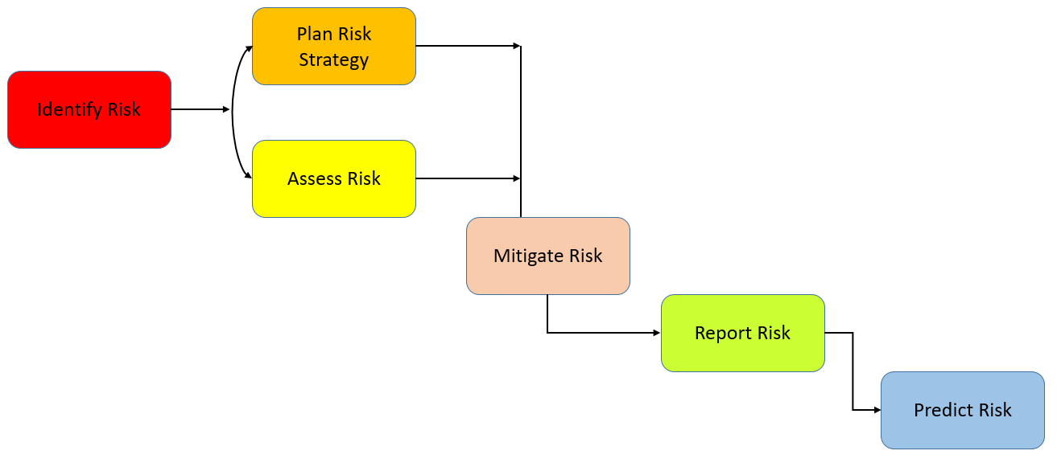

* + 1. Identify risk
* Ensure requirements has been analyzed well based on the customer specification for the ABC Car Portal
* Start identifying the risk based on varios technique by conducting an interview to gather information
* Conducts brainstorming to list out the risk that may pose a threat to the used car portal
  + 1. Plan risk strategy and assess risk
* List all identified Risks so that risks can be prioritized based on threats
* Start filtering the identified risk and consider the likelihood and impact of each risk to the used car portal
* Calculate the total level of risk using the Risk Matrix to prioritize which risks to test in the test plan
  + 1. Mitigate risk
* Contacting each stakeholder and setting up meetings to discuss possible solution to the issue/risk and getting updates on the risk which ghas been manage previously for the portal (Thomas , 2022)
* Create a centralized system where all risk data are recorded and can become a reference for future management of risk (Hunt, 2019)
* Consulting with risk analyst or an expert in order to eliminate or contain the risk as much as possible.
  + 1. Report risk

Record the outcome or log of the risk-based testing for the used car portal and forward the report to the development team so that the issue can be fixed for the failed test cases.

* + Predict risk

Predict the outcome of future risk based on assessed risk and creating a contingency plan as a workaround for any unforeseen events.

* 1. **Communicate the details of the strategy and test planning to the key stakeholders with proper justifications**
     1. Justify the selection of test methods based on qualified risk to a project

|  |  |
| --- | --- |
| Type of Testing | Main Purpose |
| Functional Testing | The purpose of this testing is to confirm that the user and administrator features—such as login, registration, viewing car details, posting a new car with details, and searching for cars by make, model, price, and registration—that are included in the project requirement specification work as intended. |
| Security Testing | This testing reveals the used vehicle portal's weaknesses, risks, and threats from malicious intrusions that could result in the loss of data, money, or the reputation of the portal. The use of malicious SQL statements injected into an input field, such as the search bar, to obtain and update data in the portal database is one method of attack that is possible (WHAT IS SQL INJECTION?, n.d.). The confidentiality of user data will be jeopardized, and the portal will become exposed, exposing the design of the database. In order to properly authenticate or validate the user during the login stage and authorize which links a user can access based on their role, Spring Security is essential. |
| Performance Testing | In order to ensure a better user experience, this testing focuses on analyzing the speed and responsiveness of the portal web pages, such as the signup page. |
| Compatibility Testing | The portal can provide the greatest user experience across all widely used browsers and identify any compatibility issues with Chrome, Edge, or Firefox thanks to this testing, also known as cross-browser testing. |
| Portability Testing | This testing looks at the portal's adaptability in different commercially available devices such phones, tablets, and laptops in order to ensure the portal's longevity and flexibility to adapt to ongoing change, which demands constant upgrading to save expenses. |
| Usability Testing | This testing is to test how easy it is to use the used car portal and determine how usable the portal features for user to use to reach their goals such as posting a car or searching a car. |

* + 1. Communicate the details of the strategy and test planning to the key stakeholders with proper justifications
  + What is stakeholder?
  + Stakeholders can be an individual, a group, or an organization that has an impact on a software project. They may also be actively involved in the project or have an interest that could make a difference in its success or failure. They have various levels of power and responsibility throughout the project lifetime. (2021; Paspelava)Why is it important to communicate risk to key stakeholders? (Jarrad, 2019)
  + Promote Accountability

By communicating potential risk to teams and stakeholders, there will be better understanding in allocating roles and responsibilities to the right people. As a Project manager for a used car portal, it is important to make the right call on individual who can deal with an issue to ensure the project stays on track.

* + Provide realistic expectations

A transparency in communicating with stakeholders regarding a potential risk will allow them to have an awareness or realistic view on how the risk may affect the project especially the timeline. Since a significant number of finances have been invested by the stakeholders, the right gesture is to be transparent on the current situation and the stakeholders will likely have more confidence and trust on the project.

* + Unify the team

Proper communication enables a team to respond to risk instantly as there are less confusion and have better understanding on the potential risk. In this way, there is no need for an informant as the information is shared and the issue can be tackled easily.

* + How to communicate risk to stakeholders?
  + Involving the team

The entire project team is involved in risk management, especially specialists who are knowledgeable in certain risk areas or aspects of the project. Instead of relying solely on the project manager as their only point of contact, stakeholders can get more relevant information and develop realistic expectations by speaking with experts.

* + Consider stakeholder location

Due to better participation and the fact that project team members are ideally situated inside the stakeholder's region, country, or time zone, face-to-face communication helps strengthen working relationships. If there are remote team members, they can use a central hub to quickly connect with stakeholders and provide them more foresight. Team members will be able to answer to stakeholder questions and concerns with ease.

* + Utilize technology

Team members can utilize a variety of risk analysis tools, such as the cost risk tool, which can do risk analysis and fulfill financial expectations, to ensure an accurate evaluation of risk. Other technologies, such as the schedule risk tool, guarantee that the stakeholder end date is met by prioritizing risk assessments and eliminating schedule delays. Exploring and using the resources at hand will guarantee ongoing support from stakeholders and enable stakeholders to receive the appropriate data.

* + Use reporting and alerts

Setting up alerts ensures that the stakeholders are regularly engaged and aware of the potential risk. By doing so consistently, analysis can be done for common issue and report for potential issues that may emerge to stakeholders.

**1. Design suitable RBT cycle content and priorities further test cycles.**

1. Based on your car sale portal project, design and explain a suitable risk base **test cycle.**



1. Discuss each of the above stage with detail plan
2. **Communicate the details of the strategy and test planning to the key stakeholders with proper justifications**

* 1. Justify the selection of test methods based on quantified risk to a project.

|  |  |
| --- | --- |
| Type of Testing | Main Purpose |
| Functional Testing | This testing confirms the functionality of the used car portal, including login, registration, viewing car details, posting a new car, and searching for cars by make, model, price, and registration. |
| Security Testing | This testing identifies and fixes flaws that could potentially result in data breaches, theft, or malicious attacks like SQL injection harming the used car gateway. Depending on their roles, users are authenticated and given permission to visit specific URLs using Spring Security. |
| Performance Testing | To provide a great user experience, this assessment assesses the used automobile portal's responsiveness and speed.. |
| Compatibility Testing | This testing ensures that the used car portal works well across different browsers, such as Chrome, Edge, and Firefox, to deliver an optimal user experience. |
| Portability Testing | This testing assesses the adaptability of the used car portal on different devices, such as phones, tablets, and laptops, to ensure that the portal can adapt to changing technology and remain cost-effective. |
| Usability Testing | This testing evaluates how user-friendly the used car portal is and how easy it is for users to achieve their goals, such as posting a car or searching for a car. |

* 1. Communicate the details of your strategy and test planning to the key stakeholders with proper justifications

***Reference Link:***

<https://www.safran.com/blog/how-to-communicate-risk-to-project-stakeholders>

1. **Task 6**

Create the following items under **“Testing Results”** in Project Report

1. Execute the risk-based test pan and log the test results

2. Modify the risk-based test procedure with the reasons

## Execute the risk-based test pan and log the test results

* 1. Functional Testing (Unit Testing)

**Example**

* + 1. **Functional Testing (UAT)**

|  |  |  |  |
| --- | --- | --- | --- |
| **Requirements** | **Test Scenario ID** | **Test Scenario** | **Number of test Cases** |
| Functional Testing | TS001 - Unit Testing | Validating Registration functionality | 1 |
| TS002 - Unit Testing | Validating Login functionality | 1 |
| TS003 - Unit Testing | Check if car data can be added/save | 1 |
| TS004 - Unit Testing | Check if car can be search | 1 |
| TS005 - Unit Testing | Check if bidding price can be saved | 1 |

|  |  |  |  |  |  |  |  |  |
| --- | --- | --- | --- | --- | --- | --- | --- | --- |
| **Scenario ID** | **Test Case ID** | **Test Case** | **Preconditions** | **Steps** | **Test Data** | **Expected Result** | **Actual Result** | **Pass/ Fail** |
| TS001 | TC001 | Check if registered user credentials can be saved | Implementation of ABC Car Portal is complete with all webpages and navigation links and uploaded on localhost server | Run Test script shown in screenshot below | Name= kemal jhon  Username=kemal  Email=kemal@gmail.com Password= kemal | After checking, junit should return a passing result as user data can be save | As expected, | Pass |

|  |  |  |
| --- | --- | --- |
| Evidence |  |  |

|  |  |  |  |  |  |  |  |  |
| --- | --- | --- | --- | --- | --- | --- | --- | --- |
| **Scenario ID** | **Test Case ID** | **Test Case** | **Preconditions** | **Steps** | **Test Data** | **Expected Result** | **Actual Result** | **Pass/ Fail** |
| TS002 | TC001 | Check if user credential is existing in the system | Implementation of ABC Car Portal is complete with all webpages and navigation links and uploaded on localhost server | Run Test script shown in screenshot below | Username = kemal | After checking, junit should return a passing result as user data exist/present in the system | Not As expected, | Fail |

|  |  |  |
| --- | --- | --- |
| Evidence |  |  |

|  |  |  |  |  |  |  |  |  |
| --- | --- | --- | --- | --- | --- | --- | --- | --- |
| **Scenario ID** | **Test Case ID** | **Test Case** | **Preconditions** | **Steps** | **Test Data** | **Expected Result** | **Actual Result** | **Pass/ Fail** |
| TS003 | TC001 | Validate if car information can be added successfully | Implementation of ABC Car Portal is complete with all webpages and navigation links and uploaded on localhost server | Run Test script shown in screenshot below | name = Civic  model= Honda  Price = 33000 Make Year =2022  Registration Date = Jan 2023 | After checking, junit should return a passing result as car data can be saved | As expected, | Pass |

|  |  |  |
| --- | --- | --- |
| Evidence |  |  |

|  |  |  |  |  |  |  |  |  |
| --- | --- | --- | --- | --- | --- | --- | --- | --- |
| **Scenario ID** | **Test Case ID** | **Test Case** | **Preconditions** | **Steps** | **Test Data** | **Expected Result** | **Actual Result** | **Pass/ Fail** |
| TS004 | TC001 | To test searching for a car | Implementation of ABC Car Portal is complete with all webpages and navigation links and uploaded on localhost server | Run Test script shown in screenshot below | Search input = Civic | After checking, junit should return a passing result as any car can be search with matching requirements | As expected, | Pass |

|  |  |  |
| --- | --- | --- |
| Evidence |  |  |

|  |  |  |  |  |  |  |  |  |
| --- | --- | --- | --- | --- | --- | --- | --- | --- |
| **Scenario ID** | **Test Case ID** | **Test Case** | **Preconditions** | **Steps** | **Test Data** | **Expected Result** | **Actual Result** | **Pass/ Fail** |
| TS005 | TC001 | To test saving bidding information | Implementation of ABC Car Portal is complete with all webpages and navigation links and uploaded on localhost server | Run Test script shown in screenshot below | Bidding price = 6000  Car Name = “Civic”  User name = “rahman” | After checking, junit should return a passing result bidding information is saved | As expected, | Pass |

|  |  |  |
| --- | --- | --- |
| Evidence |  |  |

* + 1. Functional Testing (UAT Testing)

|  |  |  |  |
| --- | --- | --- | --- |
| **Requirements** | **Test Scenario ID** | **Test Scenario** | **Number of test Cases** |
| Functional Testing | UA001 - UAT Testing | Ensure user can register in the portal | 2 |
| UA002 - UAT Testing | Ensure user can login in the portal | 2 |
| UA003 - UAT Testing | Ensure user can post a car in the portal | 2 |
| UA004 - UAT Testing | Ensure user can search a car | 2 |
| UA005 - UAT Testing | Ensure user can update profile | 2 |

|  |  |  |  |  |  |  |  |  |
| --- | --- | --- | --- | --- | --- | --- | --- | --- |
| **Scenario ID** | **Test Case ID** | **Test Case** | **Preconditions** | **Steps** | **Test Data** | **Expected Results** | **Actual Results** | **Pass/Fail** |
| **UA001** | UATC001 | Check all the mandatory fields are entered | Implementation of ABC Car Portal is complete with all webpages and navigation links and uploaded on localhost server | 1. Enter URL localhost:8080 2. Click “Register” on website navigation bar 3. Enter all the fields. 4. Click Register. | Name=Lord ajri  Username = ajri  Email= [ajri@gmail.com](mailto:ajri@gmail.com) Password= ajri | After registering, user will see a successful registration message and a login link. | As expected, | Pass |

|  |  |  |
| --- | --- | --- |
| Evidence |  | Enter all fields like name, username, email and password then Register |
|  |  | Register success message appear as user has entered valid information |
|  |  | Registered data also added to ‘abcar’ database under user table |

|  |  |  |  |  |  |  |  |  |
| --- | --- | --- | --- | --- | --- | --- | --- | --- |
| UA001 | UATC002 | Check registration not blank validation working correctly | Implementation of ABC Car Portal is complete with all webpages and navigation links and uploaded on localhost server | 1. Enter URL localhost:8080 2. Click “Register” on website navigation bar   4. Click Register without entering  any information. | Name= Username = Email= Password= | After submitting the register data, user will see the browser default validation message ‘Please fill out this field’ | As expected, | Pass |

|  |  |  |
| --- | --- | --- |
| Evidence |  | User will not be able to register with an empty field due to browser default validation and form required validation |
|  |  |  |

|  |  |  |  |  |  |  |  |  |
| --- | --- | --- | --- | --- | --- | --- | --- | --- |
| UA002 | UATC002 | Check login validation working correctly | Implementation of ABC Car Portal is complete with all webpages and navigation links and uploaded on localhost server | 1. Enter URL localhost:8080 2. Enter password incorrectly   4. Click Log In without entering  any information. | Username = kemal  Password= kemal | After login, user will see an error message to try again or register back | As expected, | Pass |

|  |  |  |
| --- | --- | --- |
| Evidence |  | User need to sign in after registration using username and password registered |
|  |  | User will be directed to the home page once login is successful |

|  |  |  |  |  |  |  |  |  |
| --- | --- | --- | --- | --- | --- | --- | --- | --- |
| **Scenario ID** | **Test Case ID** | **Test Case** | **Preconditions** | **Steps** | **Test Data** | **Expected Results** | **Actual Results** | **Pass/Fail** |
| **UA003** | UATC001 | Check if user can successfully post a car in the portal | Implementation of ABC Car Portal is complete with all webpages and navigation links and uploaded on localhost server | 1. Enter URL localhost:8080  2. Sign In into the portal  3.Click ‘Sell Now’ to post a new car in the home page  4. Enter all the fields.  5. Click Post. | name = Civic  model= Honda  Price = 33300  Make Year = 2022  Registration Date = Dec.2023 | After posting a car, user will see a success message and view car detail  link. | As expected, | Pass |

|  |  |  |
| --- | --- | --- |
| Evidence |  | User can add car to sell in the home page by clicking ‘Sell Now’ button |
|  |  | Success message appear once the user posts the car to sell with the link to view the car detail |
|  |  | Car detail posted appear in the car detail page |
|  |  | Posted car information is added to ‘abcar’ database |

|  |  |  |  |  |  |  |  |  |
| --- | --- | --- | --- | --- | --- | --- | --- | --- |
| UA003 | UATC002 | Check post car form not blank validation working correctly | Implementation of ABC Car Portal is complete with all webpages and navigation links and uploaded on localhost server | 1. Enter URL localhost:8080  2. Sign In into the portal  3. Click ‘Sell Now’ to post a new car in the home page  4. Click Post without entering any information. | name = model= Price = Make Year =  Registration Date = | After submitting the post data, user will see the browser default validation message ‘Please fill out this  field’ | As expected, | Pass |

|  |  |  |
| --- | --- | --- |
| Evidence |  | User will not be able to post car with an empty field due to browser default validation and form required validation |

|  |  |  |  |  |  |  |  |  |
| --- | --- | --- | --- | --- | --- | --- | --- | --- |
| **Scenario ID** | **Test Case ID** | **Test Case** | **Preconditions** | **Steps** | **Test Data** | **Expected Results** | **Actual Results** | **Pass/Fail** |
| **UA004** | UATC001 | Check if user can search a car successfully | Implementation of ABC Car Portal is complete with all webpages and navigation links and uploaded on localhost server | 1. Enter URL localhost:8080  2. Sign In into the portal  3. Navigate to home page search bar | Search input = Lamborghini | After searching, user will see a search result of list of cars matching with the user search input | As expected, | Pass |

|  |  |  |
| --- | --- | --- |
| Evidence |  | Car can be search by make, model, registration or price. ‘Honda’ is the model to be search |
|  |  | List of ‘honda car modeL appear base on the search input |

|  |  |  |  |  |  |  |  |  |
| --- | --- | --- | --- | --- | --- | --- | --- | --- |
| UA004 | UATC002 | Ensure user can view detail of search car | Implementation of ABC Car Portal is complete with all webpages and navigation links and uploaded on localhost server | 1. Enter URL localhost:8080 2. Sign In into the portal 3. Navigate to home page search bar 4. Enter search input 5. Click Search. 6. Click ‘View Car Details’ on selected search car result | Search input = Lamborghini | User can view detail of search car selected | Not as expected, | Fail |

|  |  |  |
| --- | --- | --- |
| Evidence |  | View car details button should direct to the car detail page on the selected car |
|  |  | Whitelabel error showing up once the view button clicked, the result was not expected |

|  |  |  |  |  |  |  |  |  |
| --- | --- | --- | --- | --- | --- | --- | --- | --- |
| **Scenario ID** | **Test Case ID** | **Test Case** | **Preconditions** | **Steps** | **Test Data** | **Expected Results** | **Actual Results** | **Pass/Fail** |
| **UA005** | UATC001 | Check if user can update profile successfully | Implementation of ABC Car Portal is complete with all webpages and navigation links and uploaded on localhost server | 1. Enter URL localhost:8080  2. Sign In into the portal  3. Navigate to home page navigation bar and click Profile  3. Click on the pencil icon next to user image  4. Enter all field  5.Click ‘Update’ | Mobile = 6223456789  Address = Indonesia, Bandung | After updating, user input data mobile and address will appear on their profile page | As expected, | Pass |

|  |  |  |
| --- | --- | --- |
| Evidence |  | User can update remaining mobile and address fields in the Profile page by clicking ‘edit profile’ icon |
|  |  | User updated information appears on the profile page |
|  |  | Updated information is also added to ‘abc_car’ database under table |

|  |  |  |  |  |  |  |  |  |
| --- | --- | --- | --- | --- | --- | --- | --- | --- |
| UA005 | UATC002 | Check update profile form not blank validation working correctly | Implementation of ABC Car Portal is complete with all webpages and navigation links and uploaded on localhost server | 1. Enter URL localhost:8080  2. Sign In into the portal  3. Navigate to home page navigation bar and click Profile  4. Click on the pencil icon next to user image  5. Click ‘Update’ without entering mobile and address fields | Mobile =  Address = | After submitting the update profile data, user will see the browser default validation message ‘Please fill out this field’ | As expected, | Pass |

|  |  |  |
| --- | --- | --- |
| Evidence |  | User will not be able to update profile with an empty field due to browser default validation and form required validation |

* + 1. Performance Testing

|  |  |  |  |
| --- | --- | --- | --- |
| **Requirements** | **Test Scenario ID** | **Test Scenario** | **Number of test Cases** |
| Non-Functional Testing | PM001 – Performance Testing | Testing the performance of registration page | 2 |

|  |  |  |  |  |  |  |  |  |
| --- | --- | --- | --- | --- | --- | --- | --- | --- |
| **Scenario ID** | **Test Case ID** | **Test Case** | **Preconditions** | **Steps** | **Test Data** | **Expected Results** | **Actual Results** | **Pass/Fail** |
| **PM001** | PMC001 | To test the loading time speed of the registration page using Chrome DevTools | Implementation of ABC Car Portal is complete with all webpages and navigation links and uploaded on localhost server | 1. Enter URL localhost:8080 2. Use Chrome DevTools by right click and choose inspect 3. Click Network, choose No throttling, Fast 3G, Slow 3G 4. Click “Register” on website |  | After testing,  The loading time is expected to be less than 1s. | As expected, | Pass |

|  |  |  |
| --- | --- | --- |
| Evidence |  |  |
|  |  |  |
|  |  |  |

|  |  |  |  |  |  |  |  |  |
| --- | --- | --- | --- | --- | --- | --- | --- | --- |
| PM001 | PMC002 | To check the overall performance of the registration page using Chrome DevTools | Implementation of ABC Car Portal is complete with all webpages and navigation links and uploaded on localhost server | 1. Enter URL localhost:8080 2. Click “Register” on website navigation bar 3. Use Chrome DevTools by right click and choose lighthouse 4. Click ‘Analyze Page Load’ |  | A performance report is generated with performance expected to be above 80 – 90% | As expected, | Pass |

* + 1. Compatibility Testing

|  |  |  |  |
| --- | --- | --- | --- |
| **Requirements** | **Test Scenario ID** | **Test Scenario** | **Number of test Cases** |
| Non-Functional Testing | CB001 – Cross Browser Testing | Ensure register page maintain a consistent look and feel in different browser (Chrome, Edge, Firefox) | 3 |
| CB002 – Cross Browser Testing | Ensure login page maintain a consistent look and feel in different browser (Chrome, Edge, Firefox) | 3 |
| CB003 – Cross Browser Testing | Ensure home page maintain a consistent look and feel in different browser (Chrome, Edge, Firefox) | 3 |
| CB004 – Cross Browser Testing | Ensure car detail page maintain a consistent look and feel in different browser (Chrome, Edge, Firefox) | 3 |
| CB005 – Cross Browser Testing | Ensure profile page maintain a consistent look and feel in different browser (Chrome, Edge, Firefox) | 3 |

|  |  |  |  |  |  |  |  |  |
| --- | --- | --- | --- | --- | --- | --- | --- | --- |
| **Scenario ID** | **Test Case ID** | **Test Case** | **Preconditions** | **Steps** | **Test Data** | **Expected Results** | **Actual Results** | **Pass/Fail** |
| **CB001** | CBCC001 | Check a consistent look and feel of the register page in Google Chrome | Implementation of ABC Car Portal is complete with all webpages and navigation links and uploaded on localhost server | 1. Download ngrok for windows and add authtoken to terminal, enter ngrok http 8080 2. Paste forwarding URL in Lambdatest.com 3. Click ‘Register’ | Forwarding URL  = https://c0bb-103-111-189-31.ngrok-free.app/register_user | After testing,  Register page maintain a consistent look and feel in Google Chrome | As expected, | Pass |

|  |  |
| --- | --- |
| Evidence |  |
|  |  |

|  |  |  |  |  |  |  |  |  |
| --- | --- | --- | --- | --- | --- | --- | --- | --- |
| CB001 | CBC002 | Check a consistent look and feel of the register page in Firefox | Implementation of ABC Car Portal is complete with all webpages and navigation links and uploaded on localhost server | 1. Download ngrok for windows and add authtoken to terminal, enter ngrok http 8080 2. Paste forwarding URL in Lambdatest.com 3. Click ‘Register’ | Forwarding URL  = https://c0bb-103-111-189-31.ngrok-free.app/register_user | After testing,  Register page maintain a consistent look and feel in Firefox | As expected, | Pass |

|  |  |
| --- | --- |
| Evidence |  |

|  |  |  |  |  |  |  |  |  |
| --- | --- | --- | --- | --- | --- | --- | --- | --- |
| **Scenario ID** | **Test Case ID** | **Test Case** | **Preconditions** | **Steps** | **Test Data** | **Expected Results** | **Actual Results** | **Pass/Fail** |
| **CB002** | CBCC001 | Check a consistent look and feel of the login page in Google Chrome | Implementation of ABC Car Portal is complete with all webpages and navigation links and uploaded on localhost server | 1. Download ngrok for windows and add authtoken to terminal, enter ngrok http 8080  2. Paste forwarding URL in Lambdatest.com  Click ‘Login | Forwarding URL  = https://c0bb-103-111-189-31.ngrok-free.app/login | After testing,  Login page maintain a consistent look and  feel in Google | As expected, | Pass |

|  |  |
| --- | --- |
| Evidence |  |

|  |  |  |  |  |  |  |  |  |
| --- | --- | --- | --- | --- | --- | --- | --- | --- |
| CB002 | CBC002 | Check a consistent look and feel of the login page in Firefox | Implementation of ABC Car Portal is complete with all webpages and navigation links and uploaded on localhost server | 1. Download ngrok for windows and add authtoken to terminal, enter ngrok http 8080  2. Paste forwarding URL in Lambdatest.com  Click ‘Login | Forwarding URL = https://c0bb-103-111-189-31.ngrok-free.app/login | After testing,  Login page maintain a consistent look and feel in Firefox | As expected, | Pass |

|  |  |
| --- | --- |
| Evidence |  |

|  |  |  |  |  |  |  |  |  |
| --- | --- | --- | --- | --- | --- | --- | --- | --- |
| **Scenario ID** | **Test Case ID** | **Test Case** | **Preconditions** | **Steps** | **Test Data** | **Expected Results** | **Actual Results** | **Pass/Fail** |
| **CB003** | CBCC001 | Check a consistent look and feel of the home page in Google Chrome | Implementation of ABC Car Portal is complete with all webpages and navigation links and uploaded on localhost server | 1. Download ngrok for windows and add authtoken to terminal, enter ngrok http 8080 2. Paste forwarding URL in Lambdatest.com 3. Sign in to the portal   ’ | Forwarding URL = <https://c0bb-103-111-189-31.ngrok-free.app/login>  Username = max  Password= max123 | After testing,  Home page maintain a consistent look  and feel in Google | As expected, | Pass |

|  |  |
| --- | --- |
| Evidence |  |

|  |  |  |  |  |  |  |  |  |
| --- | --- | --- | --- | --- | --- | --- | --- | --- |
| **CB003** | CBCC002 | Check a consistent look and feel of the home page in Firefox | Implementation of ABC Car Portal is complete with all webpages and navigation links and uploaded on localhost server | 1. Download ngrok for windows and add authtoken to terminal, enter ngrok http 8080 2. Paste forwarding URL in Lambdatest.com 3. Sign in to the portal | Forwarding URL = <https://c0bb-103-111-189-31.ngrok-free.app/login>  Username = kemal  Password= kemal | After testing,  Home page maintain a consistent look  and feel in firefox | As expected, | Pass |

|  |  |
| --- | --- |
| Evidence |  |

|  |  |  |  |  |  |  |  |  |
| --- | --- | --- | --- | --- | --- | --- | --- | --- |
| **CB003** | CBCC003 | Check a consistent look and feel of the home page in Edge | Implementation of ABC Car Portal is complete with all webpages and navigation links and uploaded on localhost server | 1. Download ngrok for windows and add authtoken to terminal, enter ngrok http 8080 2. Paste forwarding URL in Lambdatest.com 3. Sign in to the portal | Forwarding URL = <https://c0bb-103-111-189-31.ngrok-free.app/login>  Username = max  Password= max123 | After testing,  Home page maintain a consistent look  and feel in Edge | As expected, | Pass |

|  |  |
| --- | --- |
| Evidence |  |

|  |  |  |  |  |  |  |  |  |
| --- | --- | --- | --- | --- | --- | --- | --- | --- |
| **Scenario ID** | **Test Case ID** | **Test Case** | **Preconditions** | **Steps** | **Test Data** | **Expected Results** | **Actual Results** | **Pass/Fail** |
| **CB004** | CBCC001 | Check a consistent look and feel of the car detail page in Google Chrome | Implementation of ABC Car Portal is complete with all webpages and navigation links and uploaded on localhost server | 1. Download ngrok for windows and add authtoken to terminal, enter ngrok http 8080 2. Paste forwarding URL in Lambdatest.com 3. Sign in to the portal 4. Click view car details   ’ | Forwarding URL = <https://c0bb-103-111-189-31.ngrok-free.app/car_details>  Username = kemal  Password= kemal | After testing,  car detail page maintain a consistent look  and feel in Google | As expected, | Pass |

|  |  |
| --- | --- |
| Evidence |  |

|  |  |  |  |  |  |  |  |  |
| --- | --- | --- | --- | --- | --- | --- | --- | --- |
| **Scenario ID** | **Test Case ID** | **Test Case** | **Preconditions** | **Steps** | **Test Data** | **Expected Results** | **Actual Results** | **Pass/Fail** |
| **CB005** | CBCC001 | Check a consistent look and feel of the profile page in Google Chrome | Implementation of ABC Car Portal is complete with all webpages and navigation links and uploaded on localhost server | 1. Download ngrok for windows and add authtoken to terminal, enter ngrok http 8080 2. Paste forwarding URL in Lambdatest.com 3. Sign in to the portal 4. Go to profile page | Forwarding URL = <https://c0bb-103-111-189-31.ngrok-free.app/profile>  Username = max  Password= max123 | After testing,  profile page maintain a consistent look  and feel in Google | As expected, | Pass |

|  |  |
| --- | --- |
| Evidence |  |

|  |  |  |  |  |  |  |  |  |
| --- | --- | --- | --- | --- | --- | --- | --- | --- |
| **CB005** | CBCC002 | Check a consistent look and feel of the profile page in Firefox | Implementation of ABC Car Portal is complete with all webpages and navigation links and uploaded on localhost server | 1. Download ngrok for windows and add authtoken to terminal, enter ngrok http 8080 2. Paste forwarding URL in Lambdatest.com 3. Sign in to the portal 4. Go to profile page | Forwarding URL = https://c0bb-103-111-189-31.ngrok-free.app/profile  Username = max  Password= max123 | After testing,  profile page maintain a consistent look  and feel in Firefox | As expected, | Pass |

|  |  |
| --- | --- |
| Evidence |  |

|  |  |  |  |  |  |  |  |  |
| --- | --- | --- | --- | --- | --- | --- | --- | --- |
| **CB005** | CBCC003 | Check a consistent look and feel of the profile page in Edge | Implementation of ABC Car Portal is complete with all webpages and navigation links and uploaded on localhost server | 1. Download ngrok for windows and add authtoken to terminal, enter ngrok http 8080 2. Paste forwarding URL in Lambdatest.com 3. Sign in to the portal 4. Go to profile page | Forwarding URL = https://c0bb-103-111-189-31.ngrok-free.app/profile  Username = max  Password= max123 | After testing,  profile page maintain a consistent look  and feel in Edge | As expected, | Pass |

|  |  |
| --- | --- |
|  |  |

* + 1. Portability Testing

|  |  |  |  |
| --- | --- | --- | --- |
| **Requirements** | **Test Scenario ID** | **Test Scenario** | **Number of test Cases** |
| Non-Functional Testing | PB001 – Portability Testing | Ensure register page maintain a consistent look and feel in different | 3 |

|  |  |  |  |  |  |  |  |  |
| --- | --- | --- | --- | --- | --- | --- | --- | --- |
| **Scenario ID** | **Test Case ID** | **Test Case** | **Preconditions** | **Steps** | **Test Data** | **Expected Results** | **Actual Results** | **Pass/Fail** |
| **PB001** | PBCC001 | To ensure all feature in the register page is visible to the user in laptop | Implementation of ABC Car Portal is complete with all webpages and navigation links and uploaded on localhost  server | 1. Enter URL localhost:8080 2. navigate to navigation bar 3. Click Register |  | After testing, all register page feature is visible to the user in laptop devices | As expected, | Pass |

|  |  |
| --- | --- |
|  |  |

|  |  |  |  |  |  |  |  |  |
| --- | --- | --- | --- | --- | --- | --- | --- | --- |
| PB001 | PBC002 | To ensure all feature in the register page is visible to the user in iPad | Implementation of ABC Car Portal is complete with all webpages and navigation links and uploaded on localhost server | 1. Enter URL localhost:8080 2. navigate to navigation bar 3. Click Register 4. right click choose inspect, Toggle device toolbar |  | After testing, all register page feature is visible to the user in iPad devices | As expected, | Pass |

|  |  |
| --- | --- |
| Evidence |  |

|  |  |  |  |  |  |  |  |  |
| --- | --- | --- | --- | --- | --- | --- | --- | --- |
| PB001 | PBC003 | To ensure all feature in the register page is visible to the user in phone | Implementation of ABC Car Portal is complete with all webpages and navigation links and uploaded on localhost  server | 1. Enter URL localhost:8080 2. navigate to navigation bar 3. Click Register 4. right click choose inspect, Toggle device toolbar |  | After testing, all register page feature is visible to the user in phone devices | As expected, | Pass |

|  |  |
| --- | --- |
| Evidence |  |

* + 1. Usability Testing

|  |  |  |  |
| --- | --- | --- | --- |
| **Requirements** | **Test Scenario ID** | **Test Scenario** | **Number of test Cases** |
| Functional Testing | UB001 – Usability Testing | Test whether the register page is user-friendly in design | 1 |
|  | UB002 – Usability Testing | Test whether the login page is user-friendly in design | 1 |
|  | UB003 – Usability Testing | Test whether the home page is user-friendly in design | 1 |
|  | UB004 – Usability Testing | Test whether the car detail page is user-friendly in design | 1 |
|  | UB005 – Usability Testing | Test whether the profile page is user-friendly in design | 1 |

|  |  |  |  |  |  |  |  |  |
| --- | --- | --- | --- | --- | --- | --- | --- | --- |
| **Scenario ID** | **Test Case ID** | **Test Case** | **Preconditions** | **Steps** | **Test Data** | **Expected Results** | **Actual Results** | **Pass/Fail** |
| **UB001** | UBC001 | Check all navigation in header and footer works properly and the content is visible in register page and user friendliness | Implementation of ABC Car Portal is complete with all webpages and navigation links and uploaded on localhost server | 1. Enter URL localhost:8080 2. Click “Register” on website navigation bar |  | All navigations links is working correctly in the register page and loading the right web pages and having a clear flow easily understood by  user | As expected, | Pass |

|  |  |
| --- | --- |
| Evidence |  |

|  |  |  |  |  |  |  |  |  |
| --- | --- | --- | --- | --- | --- | --- | --- | --- |
| **Scenario ID** | **Test Case ID** | **Test Case** | **Preconditions** | **Steps** | **Test Data** | **Expected Results** | **Actual Results** | **Pass/Fail** |
| **UB002** | UBC001 | Check all navigation in header and footer works properly and the content is visible in login page and user friendliness | Implementation of ABC Car Portal is complete with all webpages and navigation links and uploaded on localhost server | 1. Enter URL localhost:8080 2. Click ‘Login’ |  | All navigations links is working correctly in the login page and  loading the right web pages and having a clear flow easily understood by user | As expected, | Pass |

|  |  |
| --- | --- |
| Evidence |  |

|  |  |  |  |  |  |  |  |  |
| --- | --- | --- | --- | --- | --- | --- | --- | --- |
| **Scenario ID** | **Test Case ID** | **Test Case** | **Preconditions** | **Steps** | **Test Data** | **Expected Results** | **Actual Results** | **Pass/Fail** |
| **UB003** | UBC001 | Check all navigation in header and footer works properly and the content is visible in the home page and user friendliness | Implementation of ABC Car Portal is complete with all webpages and navigation links and uploaded on localhost server | 1. Enter URL localhost:8080 2. Sign in to the portal | Username = kemal  Password = kemal | All navigations links is working correctly in the home page and loading the right web pages and having a clear flow easily  understood by user | the user has to scroll up every time they want to move the page, where the activity might make the user uncomfortable | Fail |

|  |  |
| --- | --- |
| Evidence |  |

|  |  |  |  |  |  |  |  |  |
| --- | --- | --- | --- | --- | --- | --- | --- | --- |
| **Scenario ID** | **Test Case ID** | **Test Case** | **Preconditions** | **Steps** | **Test Data** | **Expected Results** | **Actual Results** | **Pass/Fail** |
| **UB004** | UBC001 | Check all navigation in header and footer works properly and the content is visible in the car detail page and user friendliness | Implementation of ABC Car Portal is complete with all webpages and navigation links and uploaded on localhost server | 1. Enter URL localhost:8080 2. Sign in to the portal 3. Click View Car details on any car shown in the home page | Username = kemal  Password = kemal | All navigations links is working correctly in the car detail page and loading the right web pages and having a clear flow easily understood by user | As expected, | Pass |

|  |  |
| --- | --- |
| Evidence |  |

|  |  |  |  |  |  |  |  |  |
| --- | --- | --- | --- | --- | --- | --- | --- | --- |
| **Scenario ID** | **Test Case ID** | **Test Case** | **Preconditions** | **Steps** | **Test Data** | **Expected Results** | **Actual Results** | **Pass/Fail** |
| **UB005** | UBC001 | Check all navigation in header and footer works properly and the content is visible in the profile page and user friendliness | Implementation of ABC Car Portal is complete with all webpages and navigation links and uploaded on localhost server | 1. Enter URL localhost:8080 2. Sign in to the portal 3. Navigate to home page navigation bar 4. Click Profile | Username = kemal  Password = kemal | All navigations links is working correctly in the profile page and loading the right web pages and having a clear flow easily understood by user | As expected, | Pass |

|  |  |
| --- | --- |
| Evidence |  |

6.1.7. Security Testing

|  |  |  |  |
| --- | --- | --- | --- |
| **Requirements** | **Test Scenario ID** | **Test Scenario** | **Number of test Cases** |
| Functional Testing | SE001 – Security Testing | Ensure user is authenticated correctly after logging in | 2 |
| SE002 – Security Testing | Ensure after logging in, user home page navigation is authorized correctly based on role assigned | 2 |
| SE003 – Security Testing | Checking for SQL injection | 1 |

|  |  |  |  |  |  |  |  |  |
| --- | --- | --- | --- | --- | --- | --- | --- | --- |
| **Scenario ID** | **Test Case ID** | **Test Case** | **Preconditions** | **Steps** | **Test Data** | **Expected Results** | **Actual Results** | **Pass/Fail** |
| **SE001** | SEC001 | To ensure Spring Security login feature is authenticated correctly for User after login with valid credentials | Implementation of ABC Car Portal is complete with all webpages and navigation links and uploaded on localhost server | 1. Enter URL localhost:8080 2. Sign in to the portal | Username = kemal  Password = kemal | User will reach to home page and see option to sell car | As expected, | Pass |

|  |  |
| --- | --- |
| Evidence |  |

|  |  |  |  |  |  |  |  |  |
| --- | --- | --- | --- | --- | --- | --- | --- | --- |
| **SE001** | SEC002 | To ensure Spring Security login feature is authenticated correctly for User after login with invalid credentials | Implementation of ABC Car Portal is complete with all webpages and navigation links and uploaded on localhost server | 1. Enter URL localhost:8080 2. Sign in to the portal | Username = kemal  Password = kemal123 | User should see an error message asking user to try again or register | Not as expected, | Fail |

|  |  |
| --- | --- |
| Evidence |  |

|  |  |  |  |  |  |  |  |  |
| --- | --- | --- | --- | --- | --- | --- | --- | --- |
| **Scenario ID** | **Test Case ID** | **Test Case** | **Preconditions** | **Steps** | **Test Data** | **Expected Results** | **Actual Results** | **Pass/Fail** |
| **SE002** | SEC001 | To ensure Spring security authorization is working correctly on the navigation bar for user | Implementation of ABC Car Portal is complete with all webpages and navigation links and uploaded on localhost server | 1. Enter URL localhost:8080  2. Sign in to the portal | Username = kemal  Password = kemal | User navigation bar does not show user and car management | As expected, | Pass |

|  |  |
| --- | --- |
| Evidence |  |

|  |  |  |  |  |  |  |  |  |
| --- | --- | --- | --- | --- | --- | --- | --- | --- |
| **SE002** | SEC002 | To ensure Spring security authorization is working correctly on the navigation bar for Administrator | Implementation of ABC Car Portal is complete with all webpages and navigation links and uploaded on localhost server | 1. Enter URL localhost:8080 2. Sign in to the portal | Username = =admin  Password = admin | User navigation bar show user and car management | As expected, | Pass |

|  |  |
| --- | --- |
| Evidence |  |

* 1. Detailed log of test results

|  |  |
| --- | --- |
|  | **Used Car Sale Portal Project** |
|  |  |
| **Reported By:** | Muhammad kemal |
| **Report Date:** | 06/05/2023 |
|  |  |
| **Tested By:** | Muhammad Kemal |
| **Tested Date:** | 06/05/2023 |
| **Testing Name/ Test Scenario ID** | Functional testing:- Unit Testing/ TS001 / TS002 / TS003 / TS004 /TS005 |
| **Total Number of Test Cases** | 5 |
| **No. of Pass:** | 4 |
| **No. of Failures:** | 1 |
| **Elapsed Time:** | 00:45:00 |
|  |  |
| **Tested By:** | Muhammad kemal |
| **Tested Date:** | 06/05/2023 |
| **Testing Name/ Test Scenario ID** | Functional testing: -UAT Testing/ UA001 / UA002 / UA003 / UA004 /UA005 |
| **Total Number of Test Cases** | 10 |
| **No. of Pass:** | 9 |
| **No. of Failures:** | 1 |
| **Elapsed Time:** | 00:35:00 |
|  |  |
| **Tested By:** | Muhammad kemal |
| **Tested Date:** | 06/05/2023 |
| **Testing Name/ Test Scenario ID** | Performance Testing/ PM001 |
| **Total Number of Test Cases** | 2 |
| **No. of Pass:** | 2 |
| **No. of Failures:** | 0 |
| **Elapsed Time:** | 00:15:00 |
|  |  |
| **Tested By:** | Muhammad kemal |
| **Tested Date:** | 06/05/2023 |
| **Testing Name/ Test Scenario ID** | Compatibility Testing/ CB001 / CB002 / CB003 / CB004 / CB005 |
| **Total Number of Test Cases** | 15 |
| **No. of Pass:** | 15 |
| **No. of Failures:** | 0 |
| **Elapsed Time:** | 00:45:00 |
|  |  |
| **Tested By:** | Muhammad kemal |
| **Tested Date:** | 06/05/2023 |
| **Testing Name/ Test Scenario ID** | Usability Testing/ UB001/ UB002/UB003/UB004/UB005 |
| **Total Number of Test Cases** | 5 |
| **No. of Pass:** | 4 |
| **No. of Failures:** | 1 |
| **Elapsed Time:** | 00:25:00 |

|  |  |
| --- | --- |
| **Tested By:** | Muhammad kemal |
| **Tested Date:** | 06/05/2023 |
| **Testing Name/ Test Scenario ID** | Security Testing/ SE001/ SE002/ SE003 |
| **Total Number of Test Cases** | 5 |
| **No. of Pass:** | 4 |
| **No. of Failures:** | 1 |
| **Elapsed Time:** | 00:25:00 |
|  |  |
| **Tested By:** | Muhammad kemal |
| **Tested Date:** | 06/05/2023 |
| **Testing Name/ Test Scenario ID** | Portability Testing/ PB001 |
| **Total Number of Test Cases** | 3 |
| **No. of Pass:** | 3 |
| **No. of Failures:** | 0 |
| **Elapsed Time:** | 00:25:00 |
| **SUMMARY LOG STATUS** | |
| **Total Number of Test Cases** | 45 |
| **Total Number of Pass** | 41 |
| **Total Number of Failures** | 4 |
| **Pass %** | 91% |
| **Total Elapsed Time** | 03:50:00 |

* 1. Modify the risk-based test procedure with the reasons

According to the log status results, 4 fail result has been recorded. Therefore, the RBT strategy needs to be modified for the abc car portal.

1. Identify Risk upon Log Fail Result
2. Identify Impacts upon it.
3. Modify RBT test plan along with Prioritization
4. Create RBT test plan with test scenario, test cases, and prioritization
5. Modify if the code is needed
6. Execute test cases
7. Create a test log report again (like above)

The test plan table are as follows with prioritization on which of the 4 fail test cases are to be retested first after modification.

|  |  |  |  |  |  |  |  |
| --- | --- | --- | --- | --- | --- | --- | --- |
| Risk Id | Test Scenario ID | Test Scenario | Test Objective | Test Priority | Risk | Technique | Expected Results |
| 1 | TS002 | Validating login functionality | To check credentials are existing in the system | High | User is not able to log in to the portal | Unit Testing | After checking, junit should return a passing result as user data exist/presen t in the system |
| 2 | UA004 | Ensure user can search and view car detail | To allow user to search a particular car in the portal | High | User is not able to find the expected car | UAT Testing | After giving the keyword user will see matched search result |
| 3 | UB003 | Test whether the home page is userfriendly in design | To ensure all navigation in header and footer works properly and the content is visible | High | the user has to scroll up every time they want to move the page, where the activity might make the user uncomfortable | Usability Testing | User will be able to use all navigation links in the home page properly and understand the flow of features available |
| 4 | SE001 | Ensure user is authenticate d correctly after logging in | To ensure Spring Security login feature is authenticat  ed correctly | High | User can not log in to the portal and reach  the home page | Security Testing | User will be able to reach respective home page based on role assigned |

Modification to source code required for each failed test cases

|  |  |  |  |
| --- | --- | --- | --- |
| Scenario ID | | Test Case ID | Test Scenario |
| SE001 | | SEC002 | To ensure Spring Security login feature is authenticated correctly for User  after login with invalid credentials |
| Modification | | | Before Modification there is no any error URL to handle if the user enter a wrong credentials    After modification mapping added for handling the login_error    So when the login_error occurred, it will handle by this controller |
| TS002 | TC001 | | Validating login functionality |
| Modification | | | Before modification I was trying to find the user by its username, but the result is error, so the mistake is the given username is different with the actual user.  simply just enter the same username between the two users being compared in the method.  simply just enter the same username between the two users being compared in the method.      After modification the users result will match with the given username |
| UA004 | UAT002 | | Ensure user can view detail of search car |
| Modification | | | It shows a whitelabel error because the carid was null, and it happens due to call the attribute mistake    After modification, the URL directly calling the attribute instead of getting the attribute using the getter method |
| UB003 | UBC001 | | Check all navigation in header and footer works properly and the content  is visible in the home page and user friendliness |
| Modification | | | Before modification, top bar and navbar are not in the same div    After Modification top bar and navbar are in the same element called “header”    Adding some styling to the element so that both navbar and topbar will always at the top of every page |

|  |  |  |  |  |  |  |  |  |
| --- | --- | --- | --- | --- | --- | --- | --- | --- |
| **Scenario ID** | **Test Case ID** | **Test Case** | **Preconditions** | **Steps** | **Test Data** | **Expected Results** | **Actual Results** | **Pass/Fail** |
| **SE001** | SEC002 | To ensure Spring Security login feature is authenticated correctly for User after login with invalid credentials | Implementation of ABC Car Portal is complete with all webpages and navigation links and uploaded on localhost server | 1. Enter URL localhost:8080 2. Sign in to the portal | Username = kemal  Password = kemal | User should see an error message asking user to try again or register | As expected, | Pass |

|  |  |  |
| --- | --- | --- |
| Evidence |  | an error message showing when the user enter wrong credentials |

|  |  |  |  |  |  |  |  |  |
| --- | --- | --- | --- | --- | --- | --- | --- | --- |
| **Scenario ID** | **Test Case ID** | **Test Case** | **Preconditions** | **Steps** | **Test Data** | **Expected Result** | **Actual Result** | **Pass/ Fail** |
| TS002 | TC001 | Check if user credential is existing in the system | Implementation of ABC Car Portal is complete with all webpages and navigation links and uploaded on localhost server | Run Test script shown in screenshot below | Username = rahman | After checking, junit should return a passing result as user data exist/present in the system | Not As expected, | Fail |

|  |  |
| --- | --- |
|  | Before Modification |
|  | After Modification, JUnit shows a passing result |

|  |  |  |  |  |  |  |  |  |
| --- | --- | --- | --- | --- | --- | --- | --- | --- |
| **Scenario ID** | **Test Case ID** | **Test Case** | **Preconditions** | **Steps** | **Test Data** | **Expected Result** | **Actual Result** | **Pass/ Fail** |
| UA004 | UATC002 | Ensure user can view detail of search car | Implementation of ABC Car Portal is complete with all webpages and navigation links and uploaded on localhost server | 1. Enter URL localhost:8080  2. Sign In into the portal  3. Navigate to home page search bar  3. Enter search input  4. Click Search.  5. Click ‘View Car Details’ on selected search car result | Search input = honda | User can view detail of search car selected | As expected, | Pass |

|  |  |  |
| --- | --- | --- |
| Evidence |  | Before modification View car details button should direct to the car detail page on the selected car |
|  |  | Turns out Whitelabel error appear once the views detail button clicked |

|  |  |  |  |  |  |  |  |  |
| --- | --- | --- | --- | --- | --- | --- | --- | --- |
| **Scenario ID** | **Test Case ID** | **Test Case** | **Preconditions** | **Steps** | **Test Data** | **Expected Result** | **Actual Result** | **Pass/ Fail** |
| UB003 | UBC001 | Check all navigation in header and footer works properly and the content is visible in the home page and user friendliness | Implementation of ABC Car Portal is complete with all webpages and navigation links and uploaded on localhost server | 1. Enter URL localhost:8080 2. Sign in to the portal | Username = kemal  Password = kemal | All navigations links is working correctly in the home page and loading the right web pages and having a clear flow easily  understood by user | the user has to scroll up every time they want to move the page, where the activity might make the user uncomfortable | Fail |

|  |  |  |
| --- | --- | --- |
| Evidence |  | Car details can be seen after modification |

|  |  |  |
| --- | --- | --- |
| Evidence |  | After modification header can always at the top of every page so that the users can easily access it |

Log Result after modification

|  |  |
| --- | --- |
| **Project ID/ Project Name:** | **Used Car Sale Portal Project** |
|  |  |
| **Reported By:** | Muhammad kemal |
| **Report Date:** | 06/05/2023 |
|  |  |
| **Tested By:** | Muhammad kemal |
| **Tested Date:** | 06/05/2023 |
| **Testing Name/ Test Scenario ID** | Functional testing: -Unit Testing/ TS001 |
| **Total Number of Test Cases** | 1 |
| **No. of Pass:** | 1 |
| **No. of Failures:** | 0 |
| **Elapsed Time:** | 00:10:00 |
|  |  |
| **Tested By:** | Muhammad kemal |
| **Tested Date:** | 06/05/2023 |
| **Testing Name/ Test Scenario ID** | Functional testing: -UAT Testing/ UA004 |
| **Total Number of Test Cases** | 1 |
| **No. of Pass:** | 1 |
| **No. of Failures:** | 0 |
| **Elapsed Time:** | 00:10:00 |
|  |  |
| **Tested By:** | Muhammad kemal |
| **Tested Date:** | 06/05/2023 |
| **Testing Name/ Test Scenario ID** | Usability Testing/ UB003 |
| **Total Number of Test Cases** | 1 |
| **No. of Pass:** | 1 |
| **No. of Failures:** | 0 |
| **Elapsed Time:** | 00:10:00 |
|  |  |
| **Tested By:** | Muhammad kemal |
| **Tested Date:** | 06/05/2023 |
| **Testing Name/ Test Scenario ID** | Security Testing/ SE001 |
| **Total Number of Test Cases** | 1 |
| **No. of Pass:** | 1 |
| **No. of Failures:** | 0 |
| **Elapsed Time:** | 00:10:00 |
|  |  |
| **SUMMARY LOG STATUS** | |
| **Total Number of Test Cases** | 4 |
| **Total Number of Pass** | 4 |
| **Total Number of Failures** | 0 |
| **Pass %** | 100% |
| **Total Elapsed Time** | 00:40:00 |

10. Task 7

Create the following items under **“Evaluation of Testing strategy”** in Project Presentation

1. Evaluate the effectiveness of the RBT strategy and assess the security testing cycles

2. Evaluate the testing strategies and compare it’s pro and cons

3. Assess the importance and environment suitability and examine the test heuristics are identified with proper justification

**10.1 Evaluate the effectiveness of the RBT strategy and assess the security testing cycles.**

1. The effectiveness of the RBT strategy

Risk-Based Testing (RBT) is an effective approach to identify potential flaws and risks in software applications early in the development lifecycle. By assessing the risks and categorizing them based on their severity, testers can prioritize testing efforts on high-risk areas and create test cases accordingly.

Security testing is an inte­gral part of software quality and is incorporated in every stage of the SDLC. Security requirements such as confidentiality, integrity, and protection against cyber-attacks are considered during the requirement stage. Authentication, authorization, and protection against common attacks like SQL injection are implemented in the car portal using Spring Security.

Authentication verifies the user's identity based on their registered credentials in the database. Authorization segregates tasks based on assigned roles. Testing for SQL injection was performed by inserting an SQL query into the input field, and the results were satisfactory as the portal did not show any return. Input validation is one of the ways to prevent SQL injection.

1. How did we implemented the security testing

Security testing was adopted in every phase of the software development lifecycle (SDLC) model, and Spring Security was used in the car portal to provide authentication, authorization, and protection against common attacks such as SQL injection. Authentication, authorization, and common attacks were tested, and the results of the testing were a pass, indicating that the implemented security measures were effective.

**10.2 Evaluate the testing strategies and compare it’s pro and cons**

|  |  |
| --- | --- |
| **Before Using RBT** | |
| **Pro** | **Cons** |
| * Allows problematic areas to be discovered earlier, leading to faster changes and improved overall test plan strategy. |  |
| * Helps prioritize extreme and high-risk level issues for testing, reducing the chance of serious problems after deployment. | * There is a risk of underestimating the severity of a low-level risk, which may cause problems in the future. |
| * Enables continuous monitoring of risk to ensure project quality and customer satisfaction | * More documentation may be required due to the frequency of re-testing problematic areas and monitoring customer satisfaction. |
| * Reduces costs by addressing high-risk issues earlier in the development cycle. | * Manual risk management can be challenging if risks are repetitive or if there is a loss of data. An automated risk management software may be necessary. |
| * Provides customer-centric reporting and progress tracking. |  |

**10.3 Assess the importance and environment suitability and examine the test heuristics are identified with proper justification**

|  |  |
| --- | --- |
| Environment | The Importance of Environment Suitability and How It Supports RBT Test Strategy |
| STS IDE | Spring Tool Suite is a program used to create Spring Boot applications, like the ABC Car Portal. It has useful tools to manage dependencies and transactions in databases. You can also test the code using JUnit, and Spring Boot Test helps to focus on just the code being tested, ignoring external factors. |
| Spring Security | Adding Spring Security to the ABC Car Portal Spring Boot application allows for implementing authentication and authorization features, which enhances website security against common attacks like SQL injection and other potential vulnerabilities. |
| MySQL Database | The storage of critical data in the ABC Car Portal greatly relies on the MySQL database, where separate tables are used to store crucial information such as user credentials, car details, car bidding, and user roles. This database is known for its robust security features, including Firewall, Encryption, and User Authentication. Particularly, after a user registers on the portal, their password is encrypted and stored securely in the MySQL database, thereby ensuring the highest level of data protection. |
| Window 10 OS | it is support all the necessary software, such as Spring Tool Suite and MySQL Workbench 8.0, have been installed to develop the ABC Car Portal securely. |
| Java Version 8 | The car portal is built using Java programming language which has security features like access modifiers to control access to fields, methods, and classes. In the portal, the POJO class fields are private and require getter and setter methods to access them. Java also offers automatic memory management which frees developers from managing garbage collection-based memory. |
| ABC Cars Pte Ltd  (Used Car Sales Portal Application) | The ABC Car Portal is being developed to meet customer requirements and must be completed within the set deadline. Full implementation of the portal requires various tests, including functional and non-functional testing. The portal is tested for unit testing, user acceptance testing (UAT), performance, compatibility, portability, usability, and security testing. |
| Test Plan | A testing plan is created based on identified risks using a Risk Matrix. The highest risk tests are performed first, and any resulting failed tests are re-tested after the issues are resolved. This approach allows for continuous monitoring of risks and maintenance of quality during the portal's development. |
| Documentation | The car portal application logs the results of different types of testing and documents failed test cases. This helps identify major risks and prioritize re-testing to maintain quality control during development. |
| Devices | To test the car website's adaptability to different hardware components, three devices were used: laptops, iPads/tablets, and mobile phones. Portability testing was carried out by utilizing Chrome DevTools and selecting the Toggle Device toolbar. |
| Browsers | To ensure that the car portal looked and felt consistent across different browsers, cross-browser testing was performed using three different browsers: Chrome, Edge, and Firefox on the Lambdatest website. Performance testing was carried out on Google Chrome using the Chrome DevTools and Lighthouse to test the portal's loading speed and overall performance. Chrome was also used for documentation research. |

**Task 8**

1. **Provide screen capture of developed pages** and hosted application in Project Presentation

login.jsp

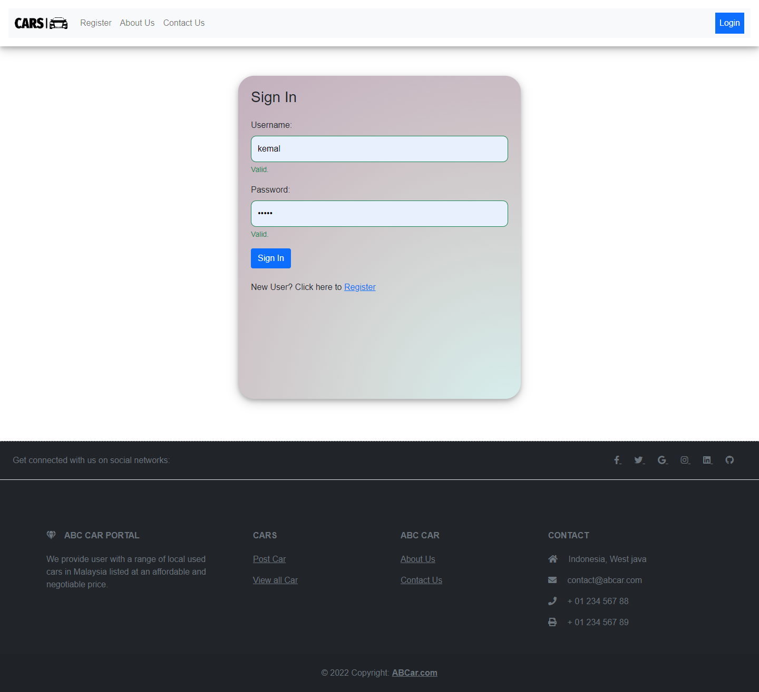

login.jsp (error message when enter the wrong credentials)

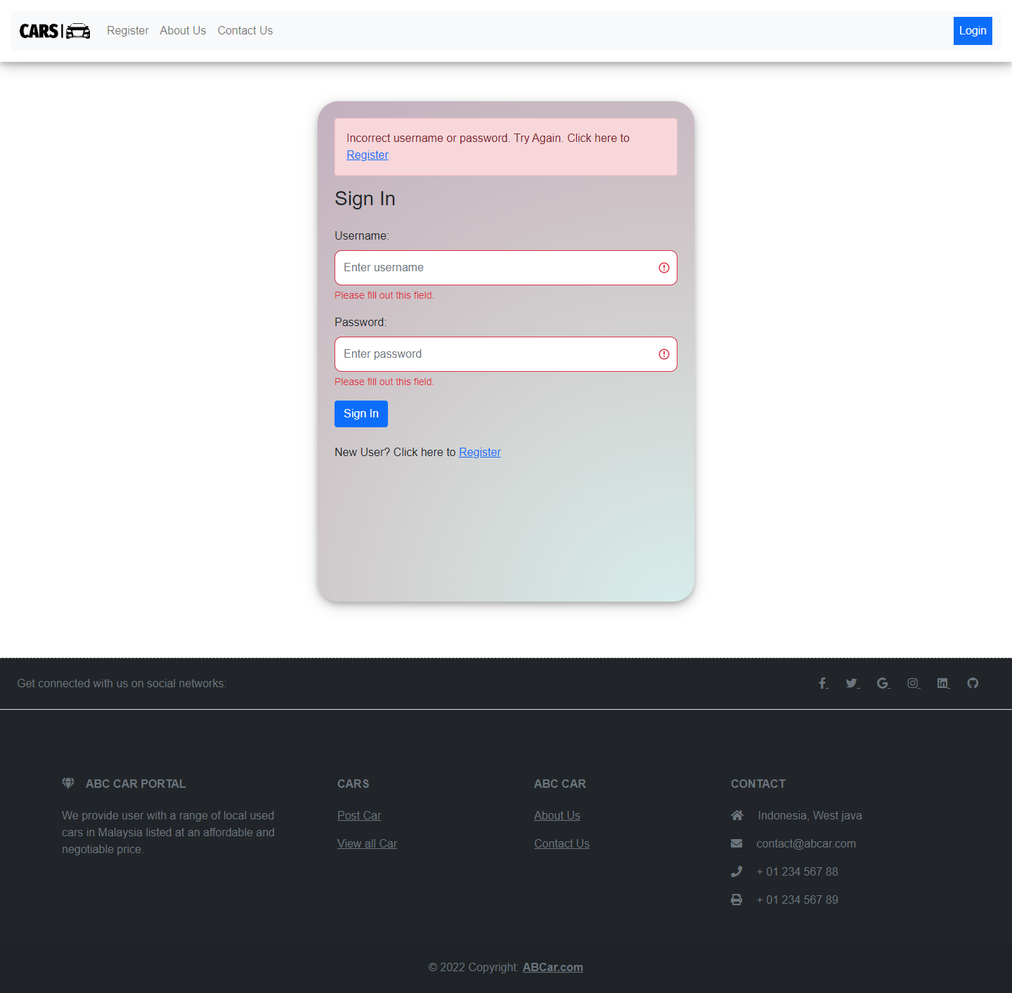

register.jsp (error message when enter the wrong credentials)

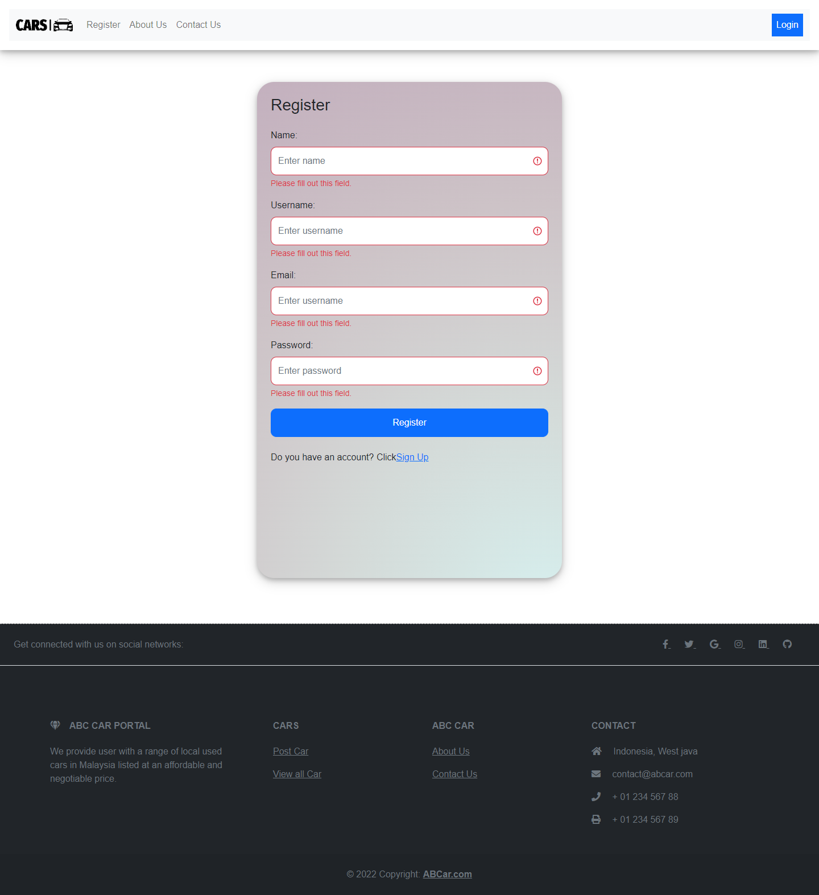

register.jsp (success message after successfully created a new account)

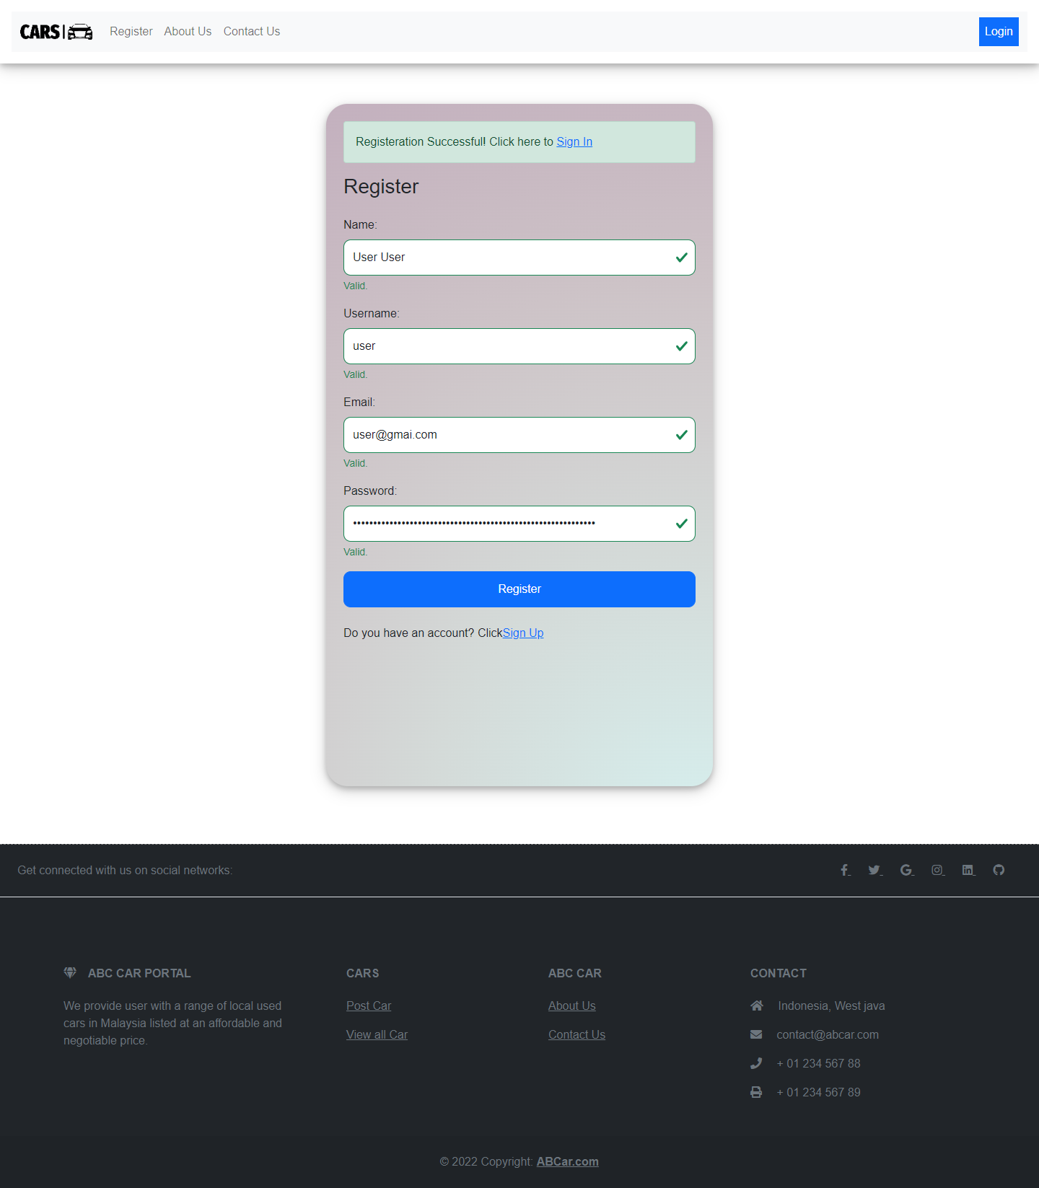

viewCars.jsp

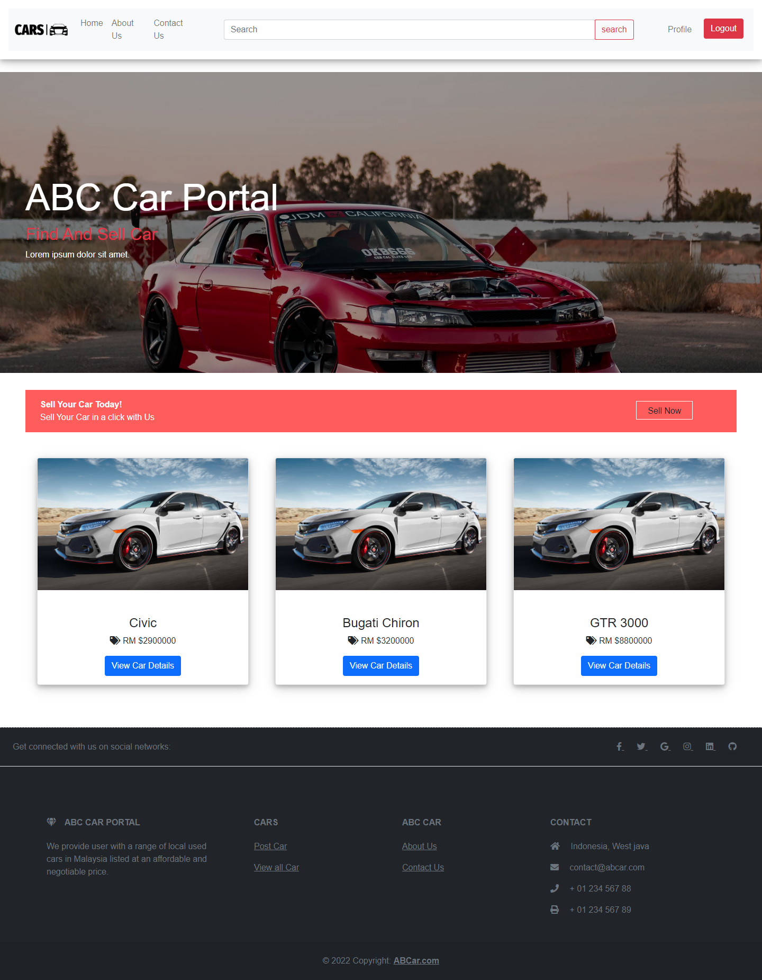

User can post to sell car by clicking this sell now button

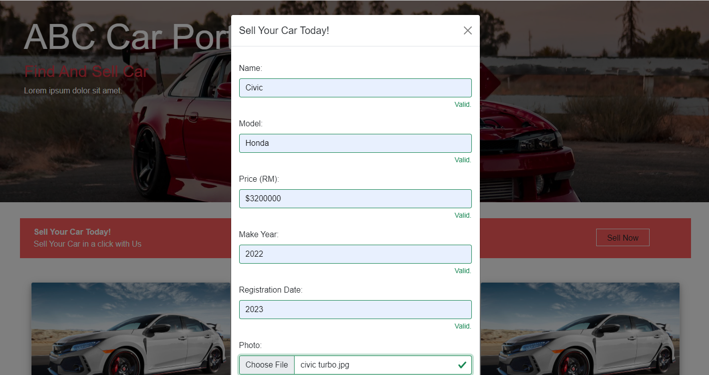

Success message appear when car successfully added

carDetail.jsp

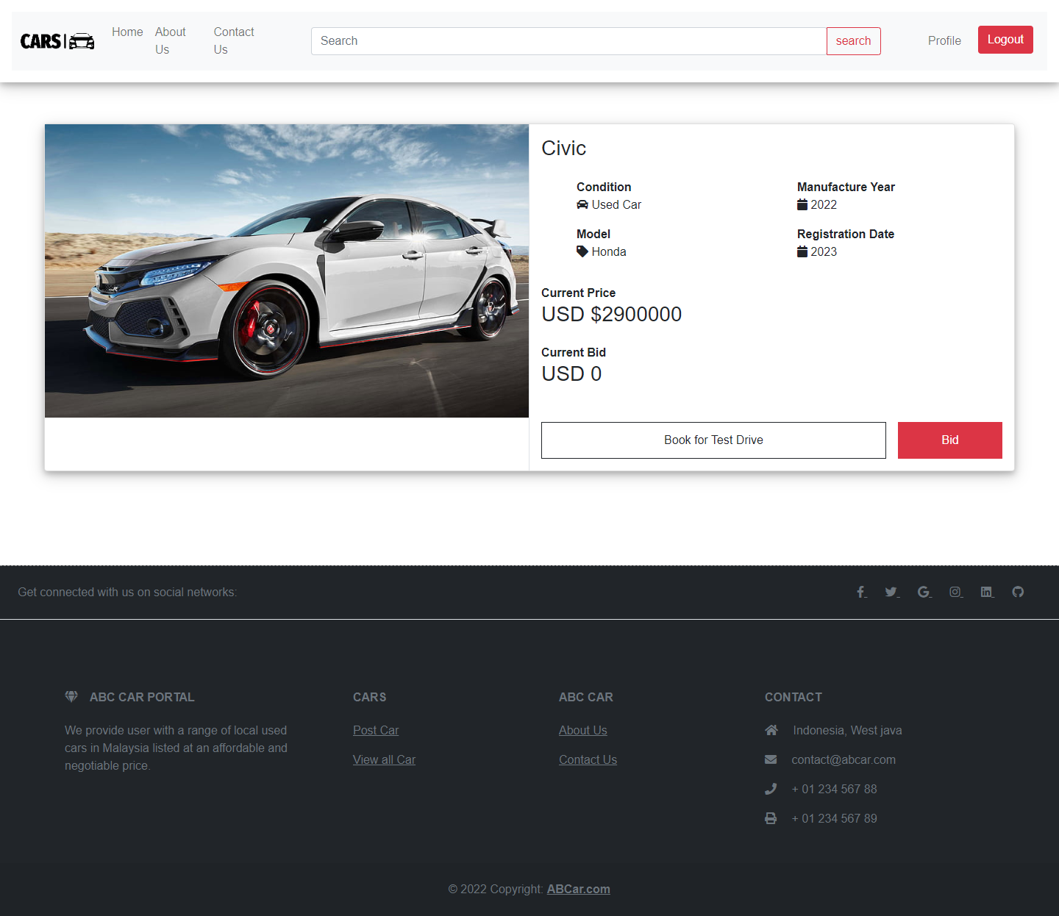

Button for booking for a test drive

For user to put their bid

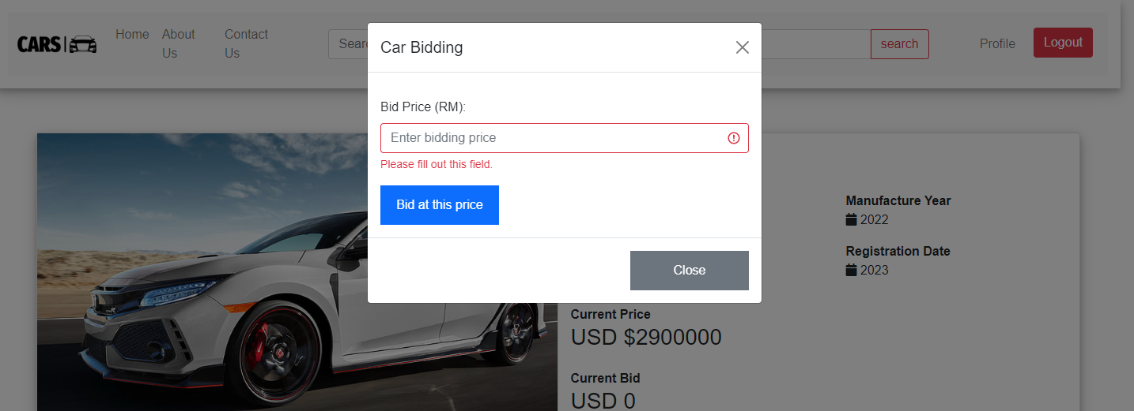

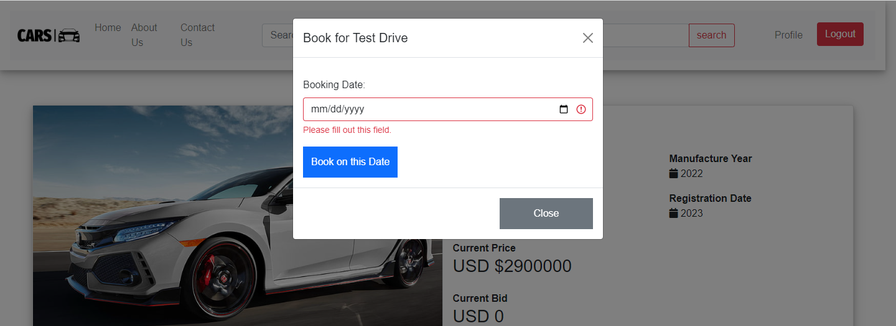

Profile.jsp

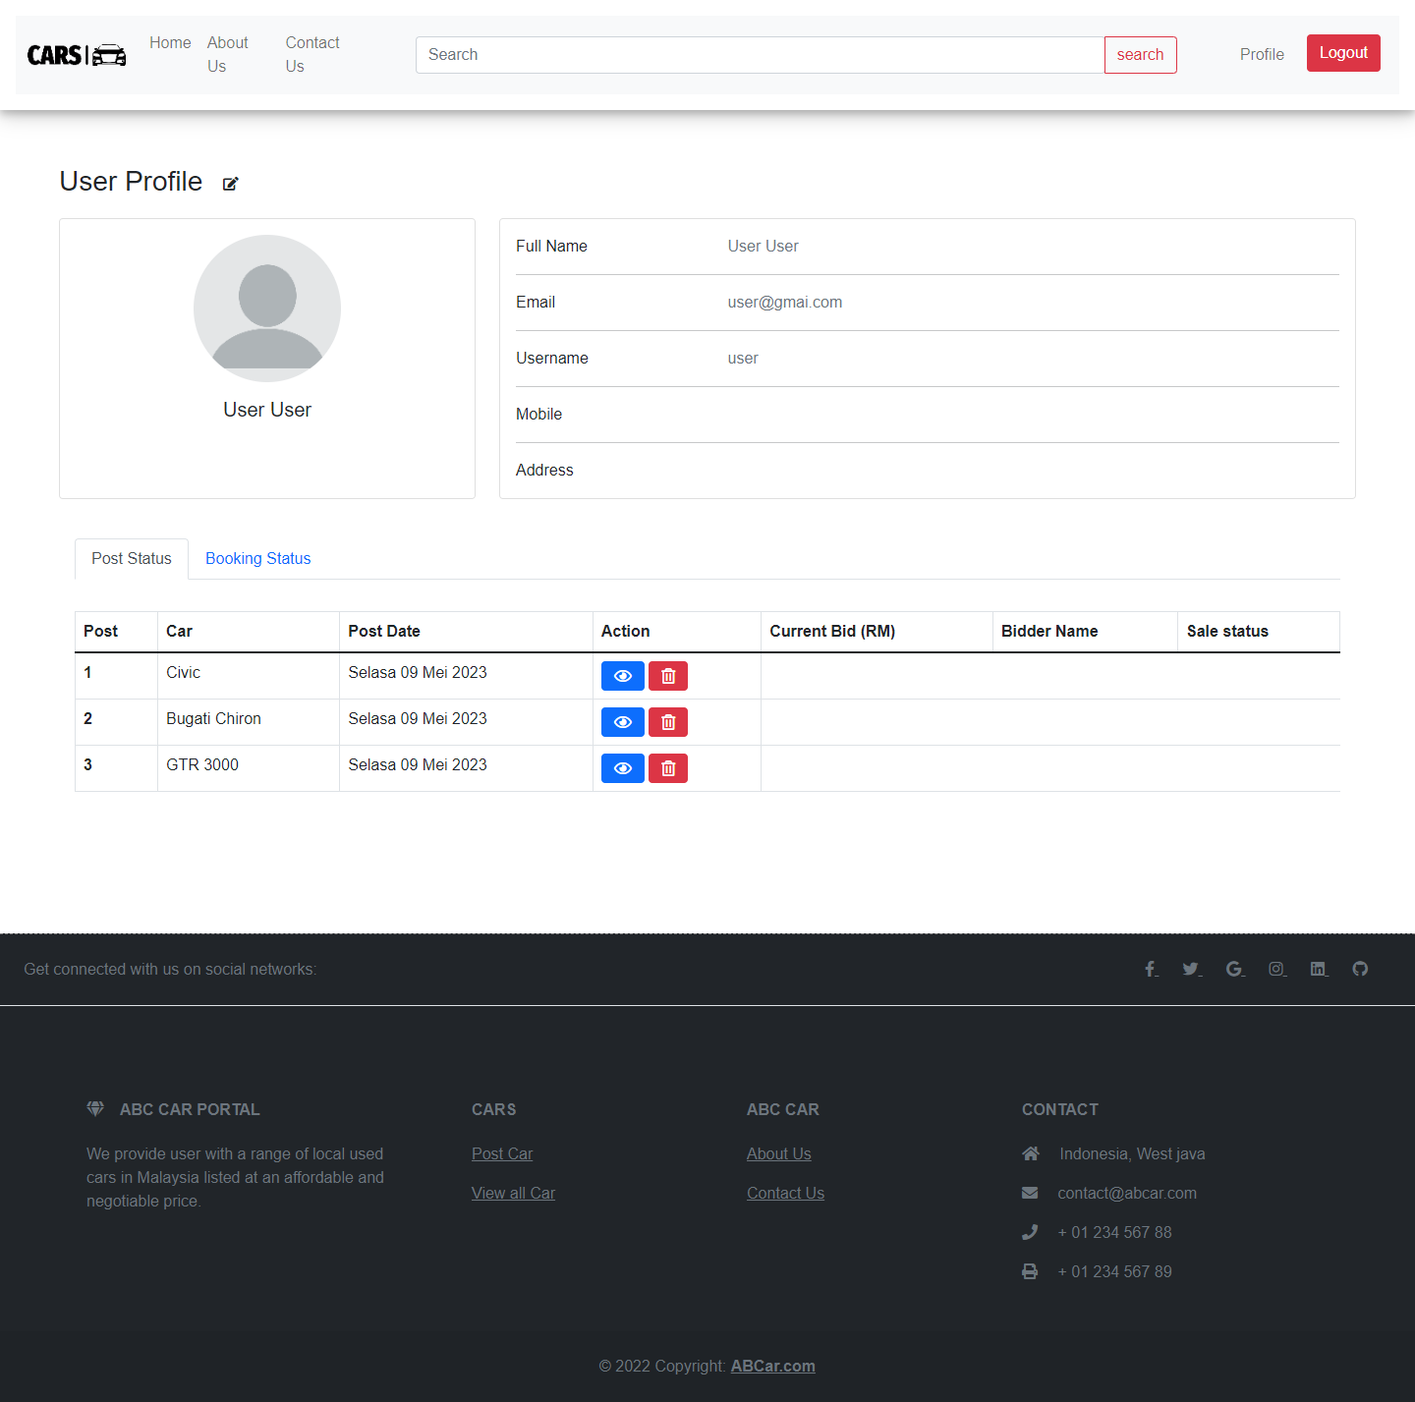

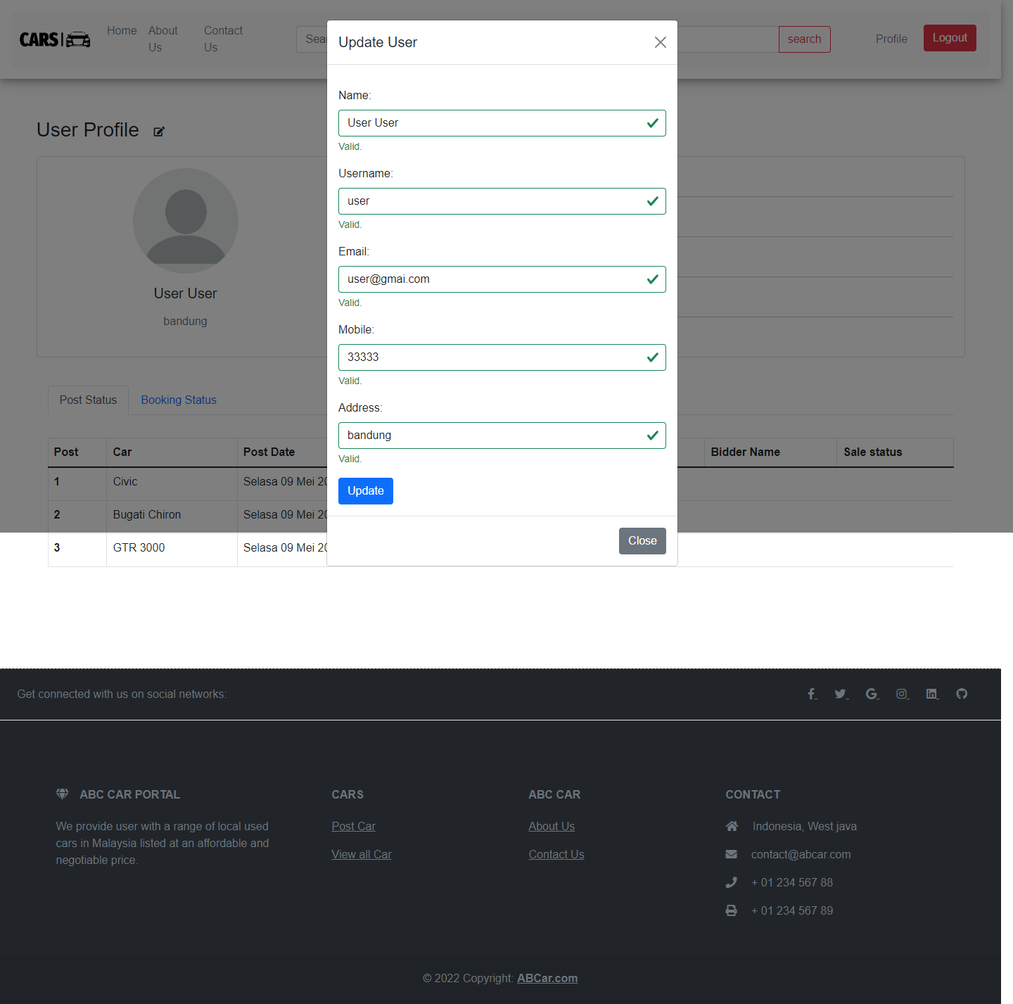

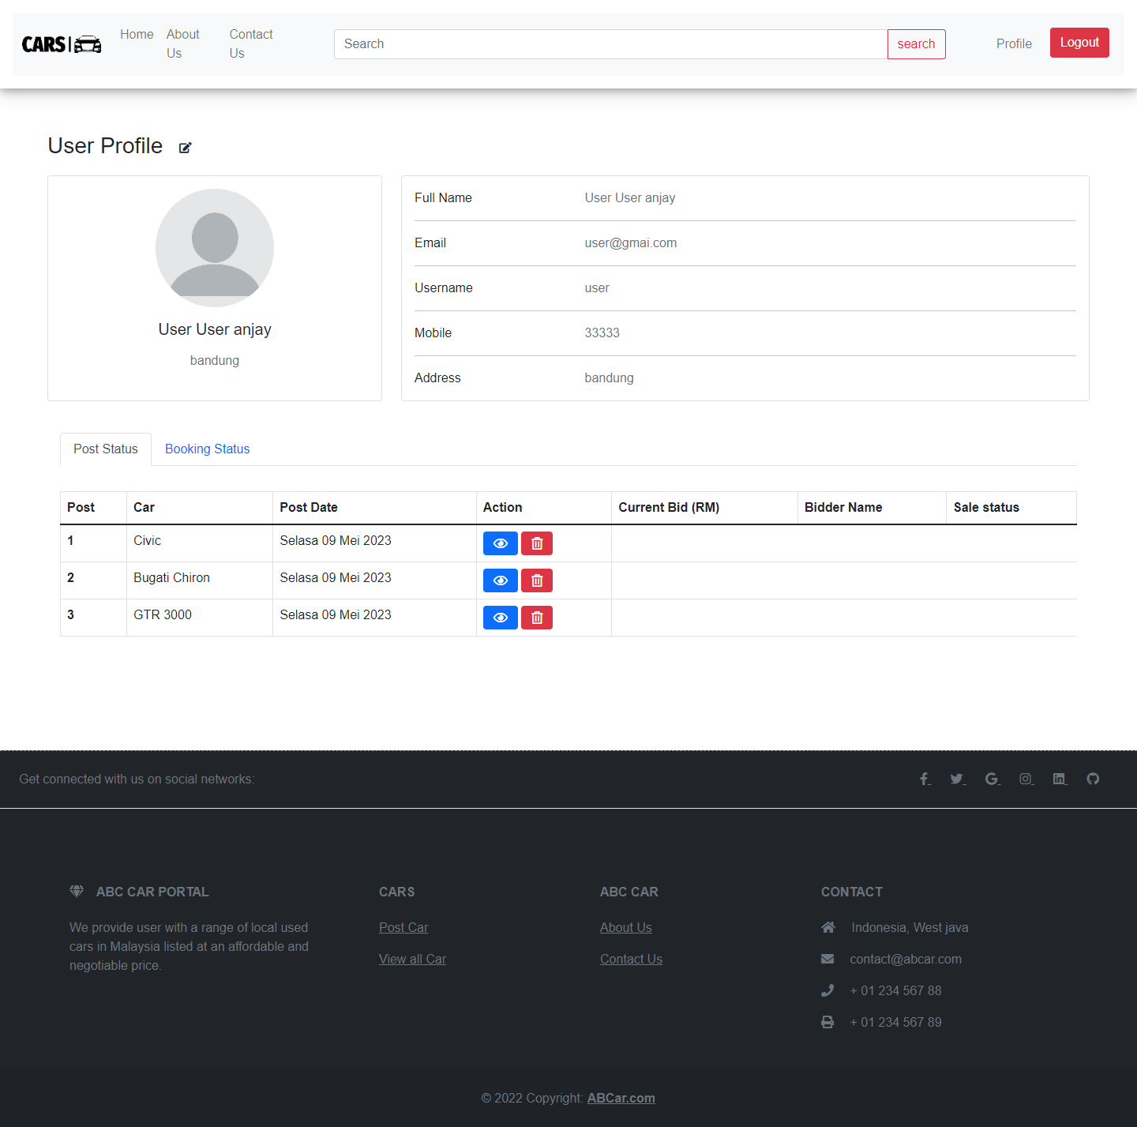

User can control and deactive their posted car

User can see their booking status on car they selected

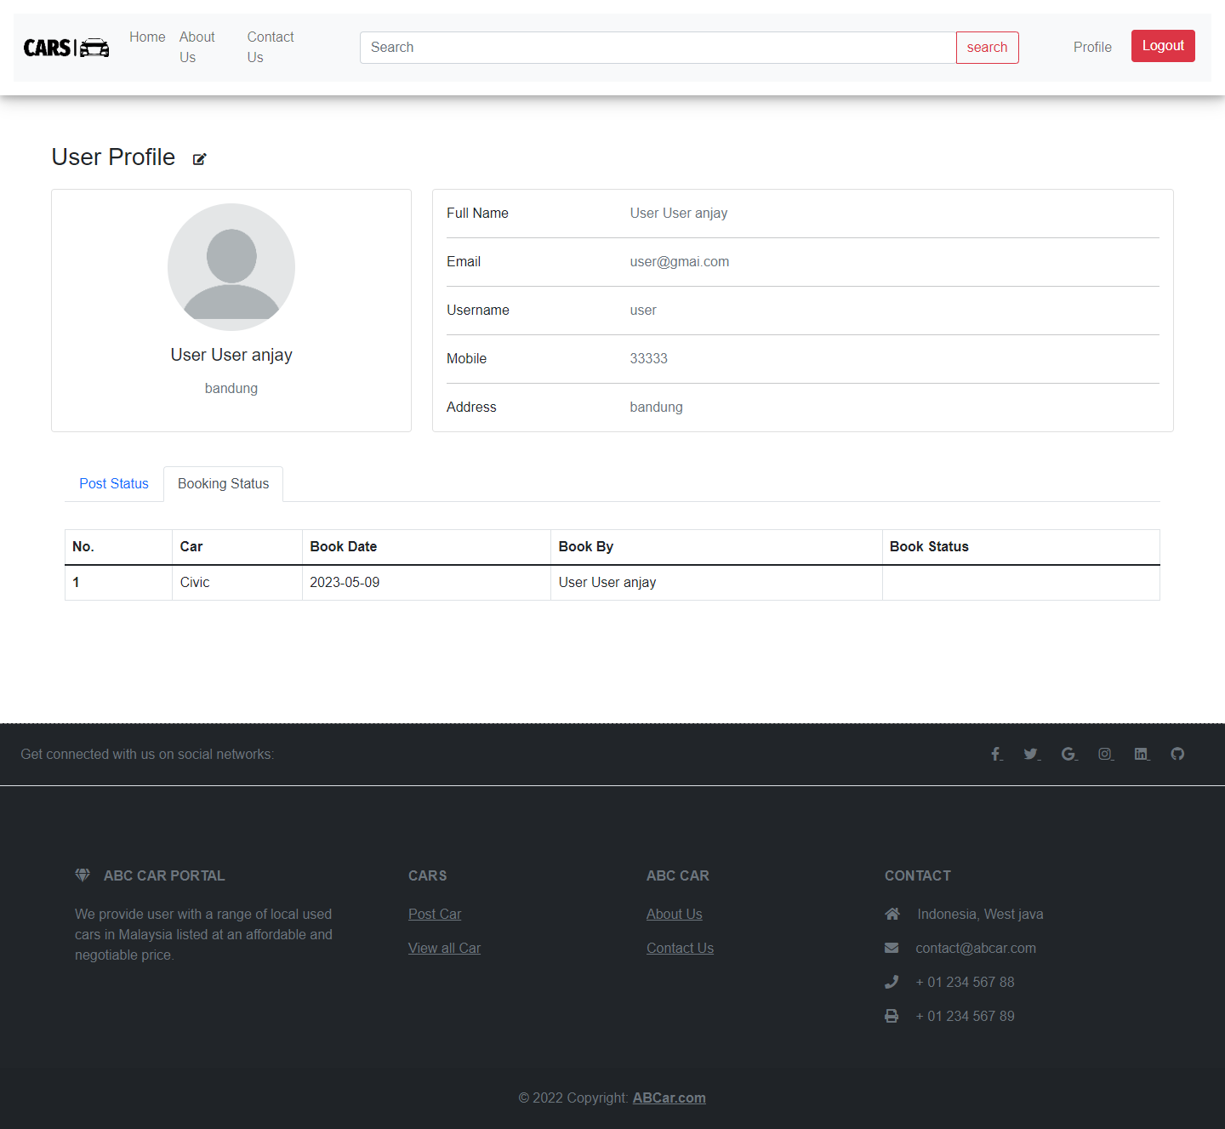

User can search car by model, make, registration or price

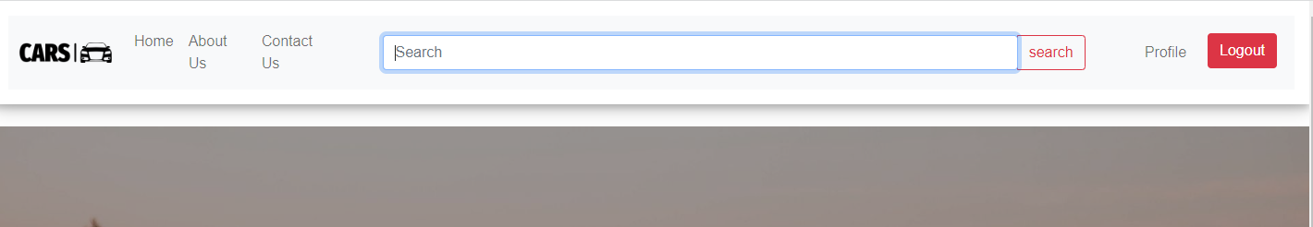

Search result for lamborghini

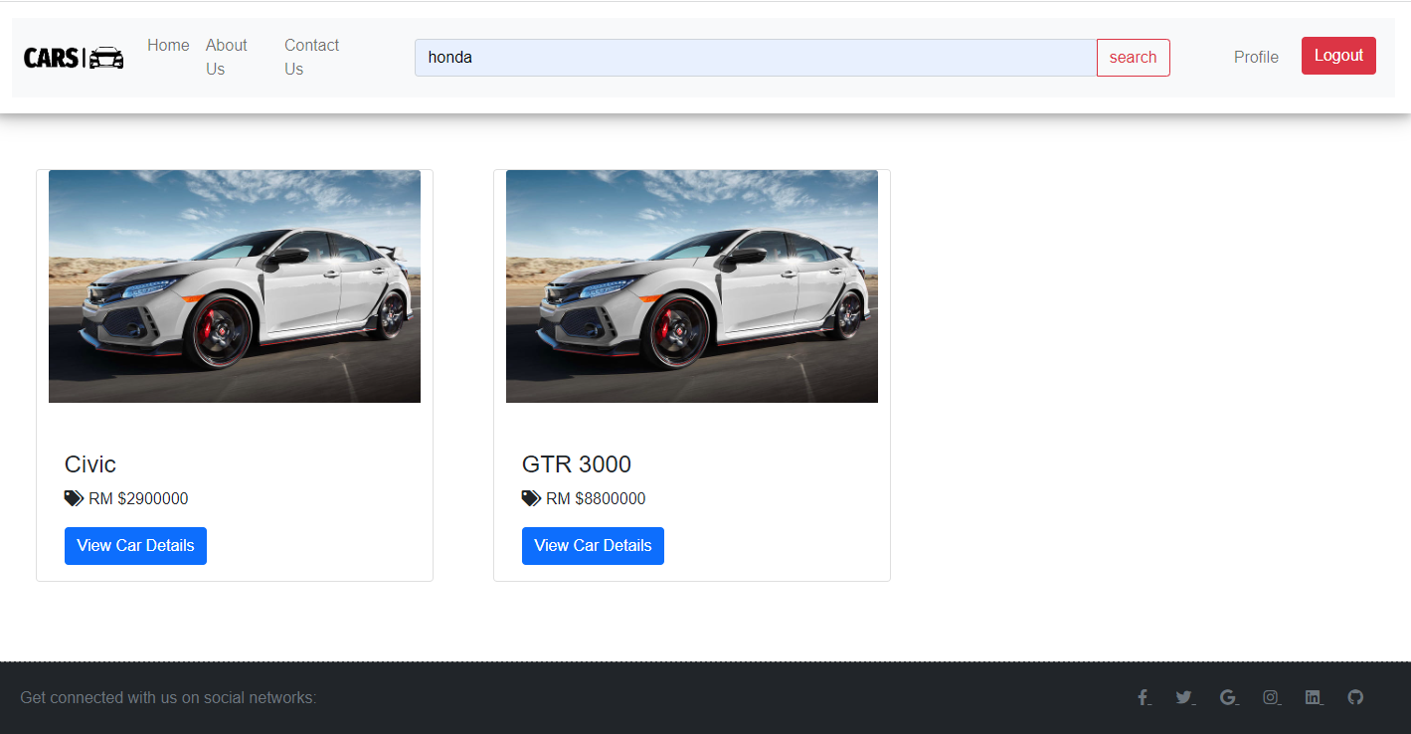

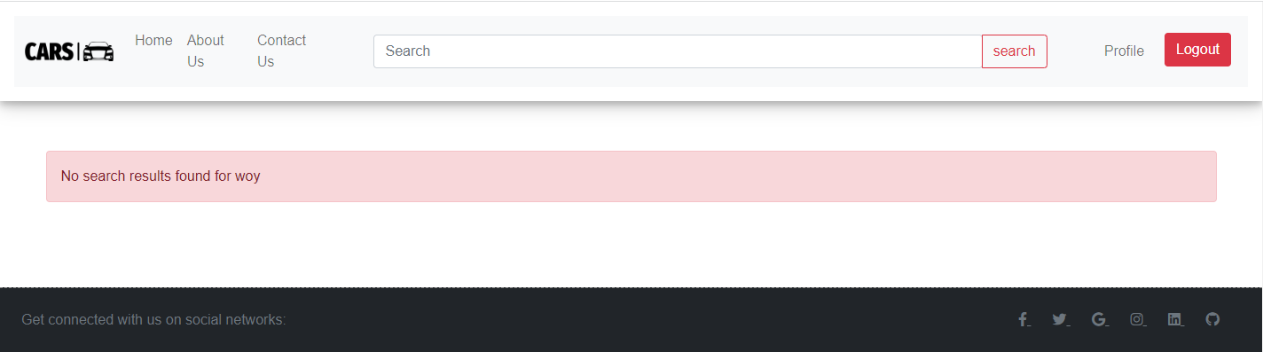

Administrator can manage all cars user data and can only see all car posted

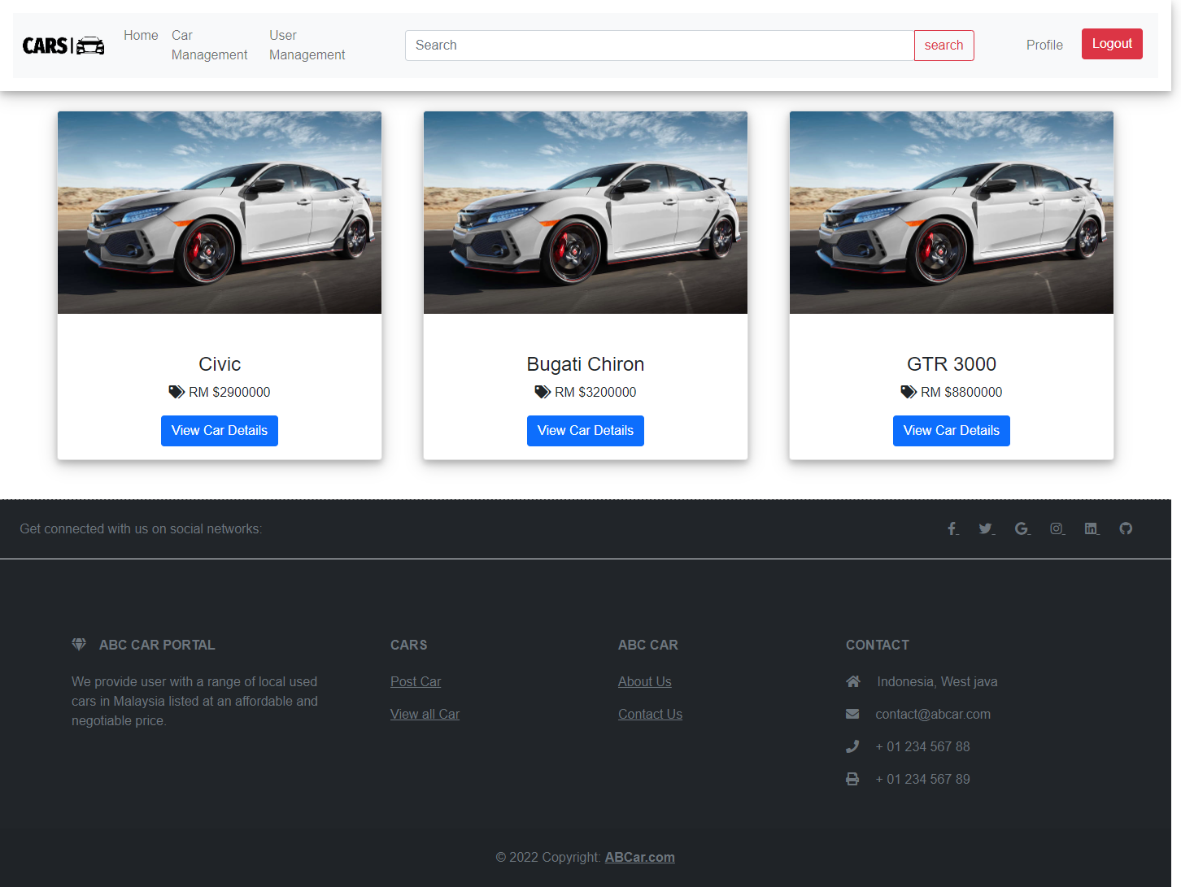

AllUser.jsp

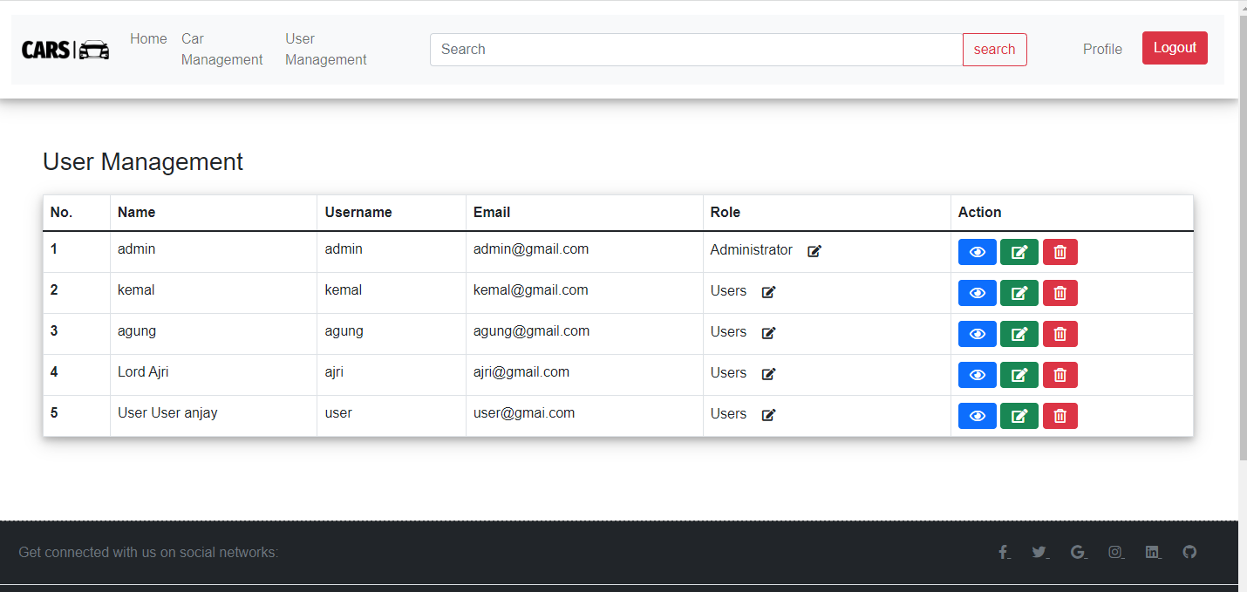

Administrator can edit user profile information

Administrator can view user profile page

Administrator can delete any user exsiting in the database

Administrator ca mark any user as an administrator

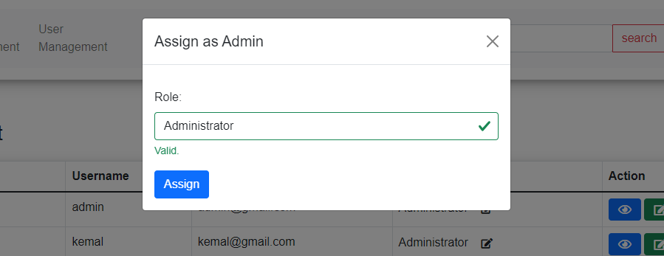

Kemal is now assigned as administrator

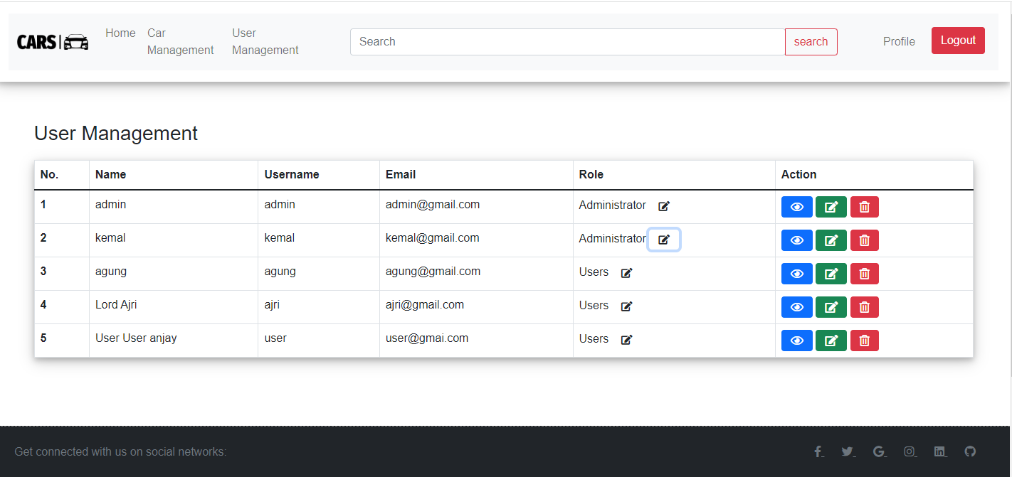

Administrator can edit any user profile information

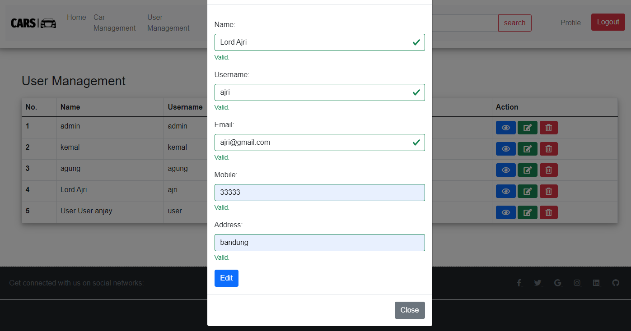

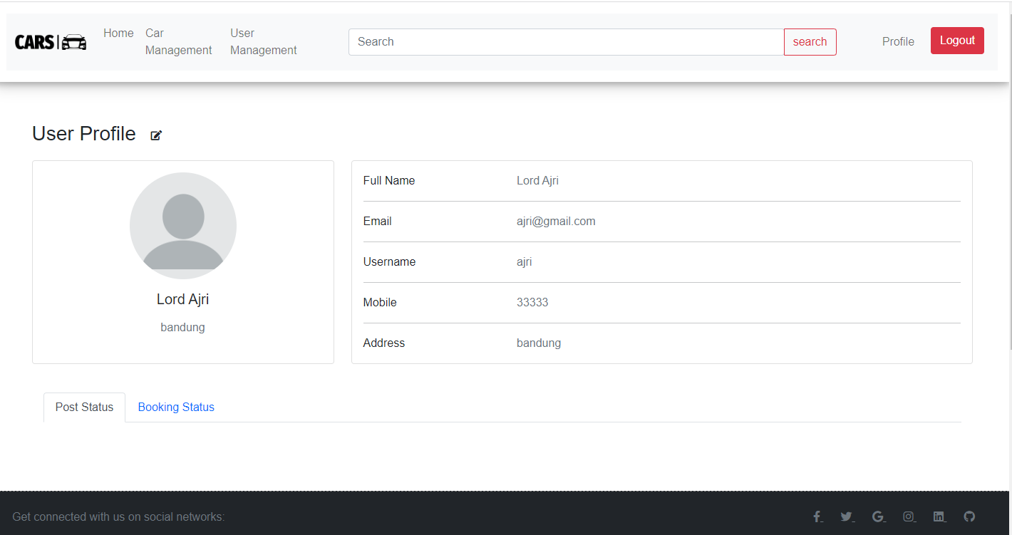

Details update by administrator

AllCar.jsp

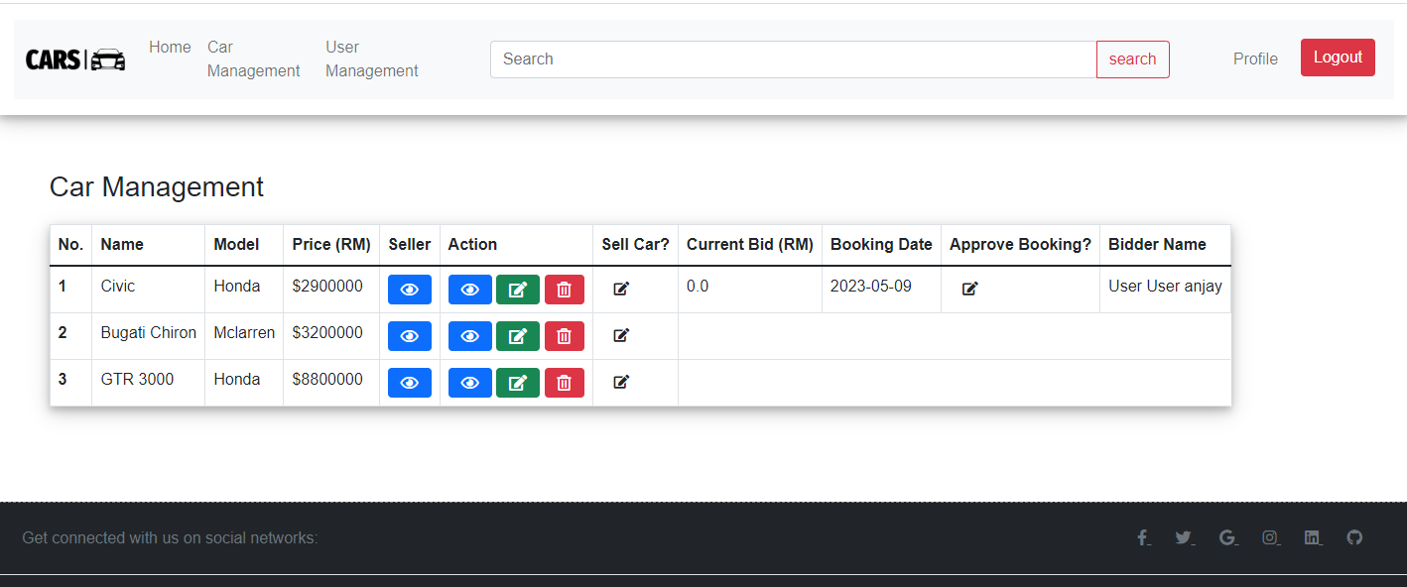

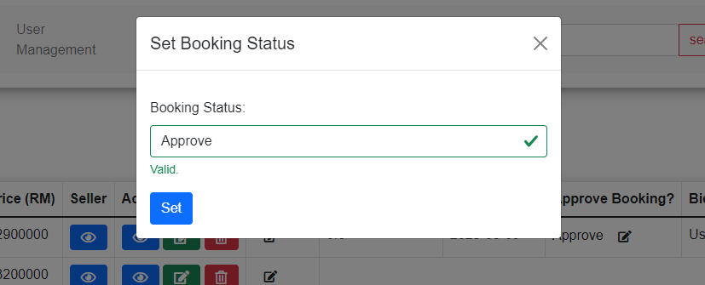

Kemal booking is now approve

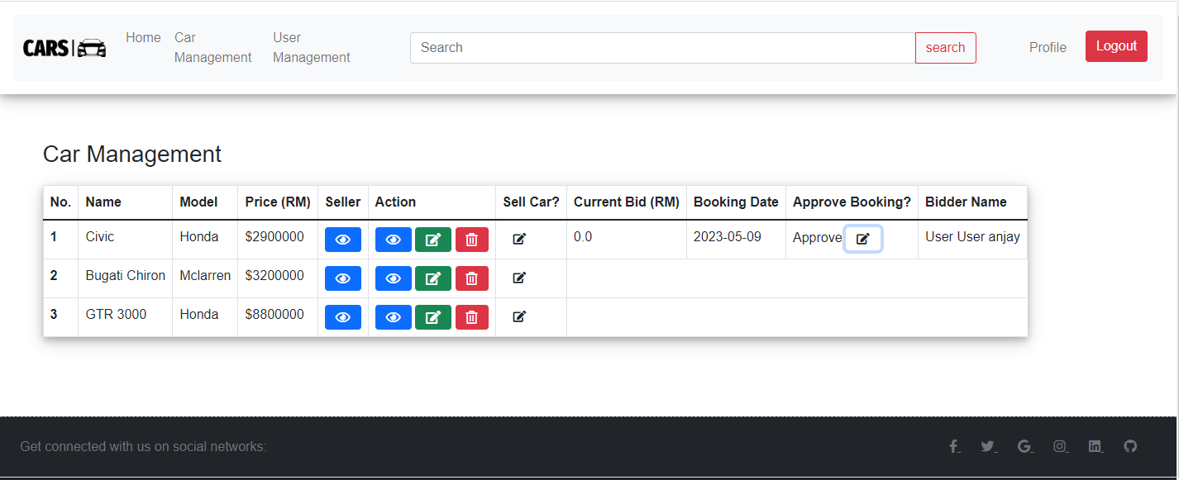

AboutUs.jsp

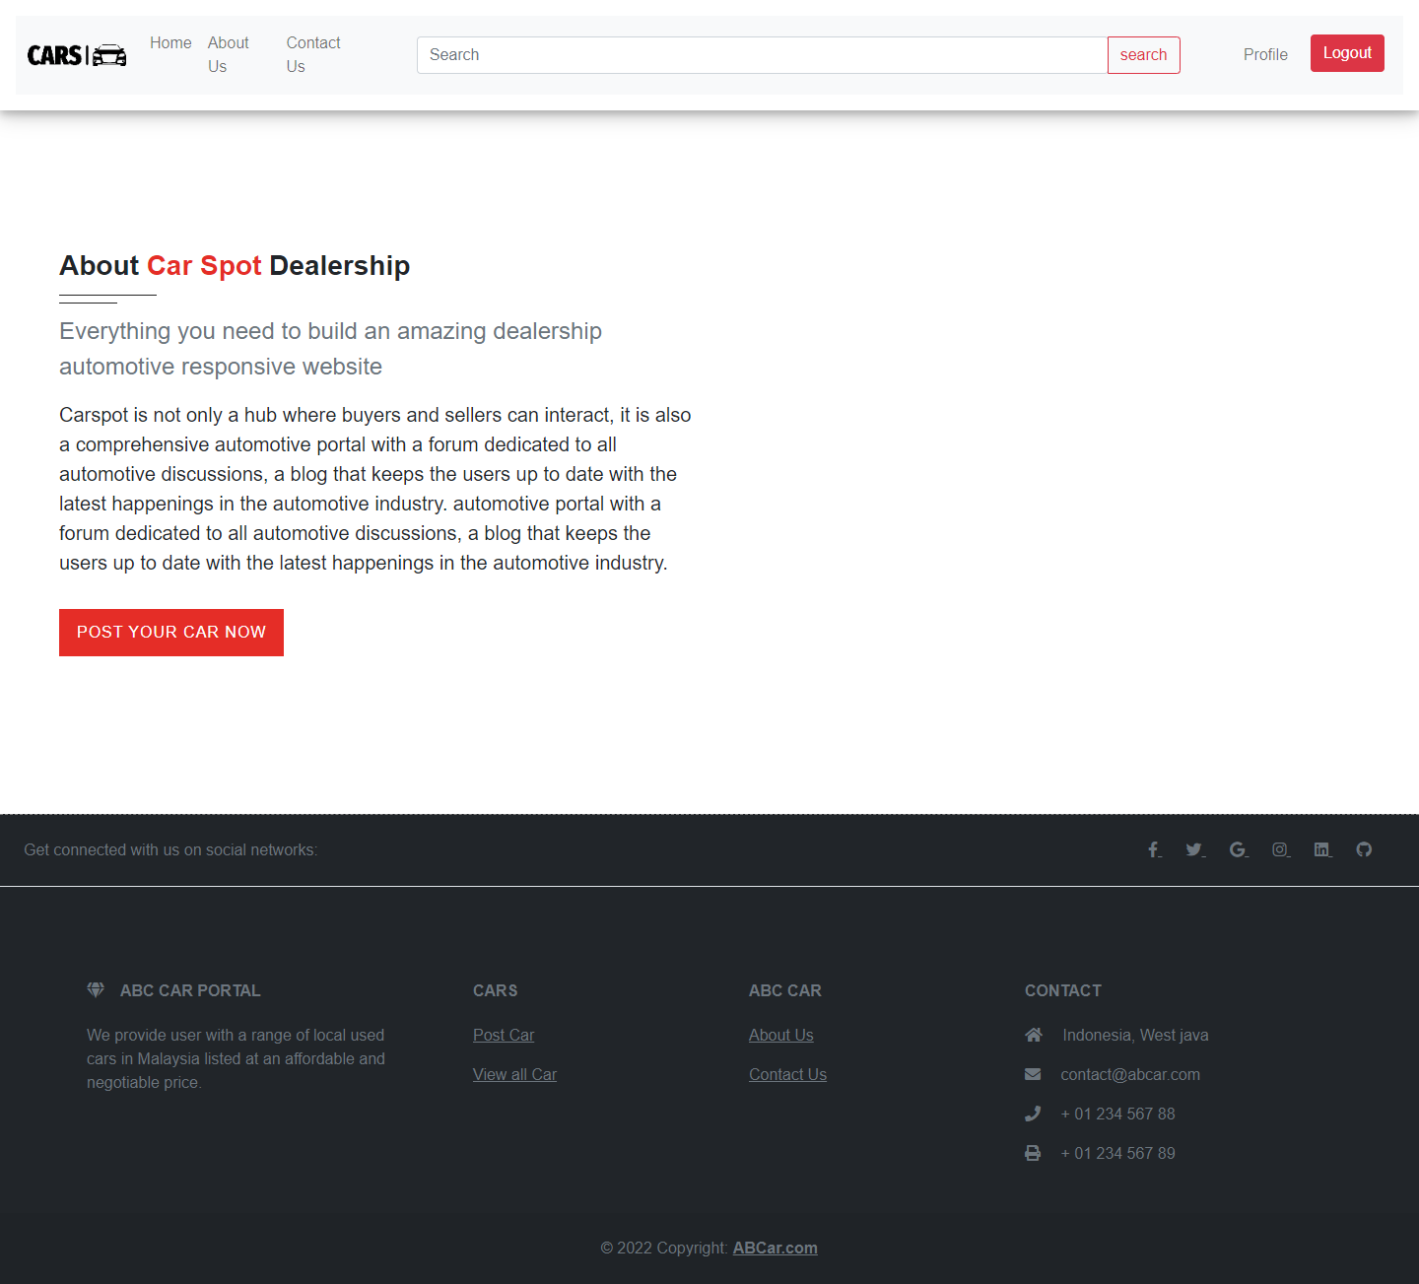

contactUs.jsp

